**Group 7**

**project management plan**

**for the**

**Therapy Booking System**

**TBS**

**01-09-2021**



Team Names:

Team Member 1: Ashraf Adel - 196280

Team Member 2: Jacinta Samir - 206562

Team Member 3: Yasmine Sameh - 206197

Team Member 4: Rahma Abdulla -196192

**Therapy Booking System, 21CSCI08ITable of Contents**

**Section Page**

**SECTION 1. OVERVIEW** **5**

1.1 Project Summary 5

1.1.1 Purpose, Scope, and Objectives 5

1.1.1.1 Purpose 5

1.1.1.2 Scope 5

1.1.1.3 Objectives 6

1.1.2 Assumptions and Constraints 6

1.1.2.1 Assumptions 6

1.1.2.2 Constraints 6

1.1.3 Project Deliverables 7

**SECTION 2. PROJECT ORGANIZATION** **8**

2.1 Project Roles and Responsibilities 8

2.1.1 Team Organizational Structure 8

2.1.2 Roles and Responsibilities 8

2.1.2.1 Analysis Manager 8

2.1.2.2 Design Manager 9

2.1.2.1 Implementation Manager 9

2.1.2.1 Testing Manager 9

**SECTION 3. TECHNICAL PROCESS** **9**

3.1 Methods, Tools and Techniques 10

3.1.1 Methods 10

3.1.2 Tools and Techniques 10

3.1.2.1 Tools 10

3.1.2.1 Techniques 10

**SECTION 4. TECHNICAL PROCESS** **11**

4.1 Project Infrastructure 11

**SECTION 5. MANAGEMENT PROCESS** **12**

5.1 Start Up 12

5.1.1 Estimation 12

5.1.1.1 Function Quiz (Jacinta) 16

5.1.1.1.1 Size Estimation (FP Technique) 16

5.1.1.1.2 Effort Estimation (COCOMO 81) 18

5.1.1.2 Function View Therapist Details (Jacinta) 18

5.1.1.2.1 Size Estimation (Albrecht II FP Technique) 19

5.1.1.2.2 Effort Estimation (COCOMO II) 19

5.1.1.3 Function Therapist Dashboard (Ashraf) 21

5.1.1.3.1 Size Estimation (FP Technique) 22

5.1.1.3.2 Effort Estimation (COCOMO 81) 23

5.1.1.4 Function Book A Session (Ashraf) 23

5.1.1.4.1 Size Estimation (Albrecht II FP Technique) 24

5.1.1.4.2 Effort Estimation (COCOMO II) 25

5.1.1.5 Function Payment (Yasmine) 27

5.1.1.5.1 Size Estimation (FP Technique) 28

5.1.1.6 Function Session Log (Yasmine) 29

5.1.1.6.1 Size Estimation (Albrecht II FP Technique) 29

5.1.1.6.2 Effort Estimation (COCOMO II) 30

5.1.1.7 Function Add Therapist (Rahma) 33

5.1.1.7.1 Size Estimation (Albrecht II FP Technique) 33

5.1.1.7.2 Effort Estimation (COCOMO II) 34

5.1.1.8 Function Remove User/Therapist (Rahma) 36

5.1.1.8.1 Size Estimation (FP Technique) 37

5.1.1.8.2 Effort Estimation (COCOMO 81) 42

5.1.1.9 Function Verification(Rahma) 42

5.1.1.9.1 Size Estimation (Albrecht II FP Technique) 42

5.1.1.9.2 Effort Estimation (COCOMO II) 43

5.1.2 Work Activities 46

5.1.2.1 Analysis Phase WBS (Rahma) 46

5.1.2.2 Design Phase WBS (Jacinta) 47

5.1.2.3 Implementation Phase WBS (Ashraf) 48

5.1.2.4 Testing Phase WBS (Yasmine) 49

5.1.2.5 Project’s WBS 50

5.1.3 Resource Allocation 51

5.2 Work Planning 52

5.2.1 Scheduling Requirements 52

5.2.1.1 Analysis’s Precedence Table & CPM Network (Rahma) 52

5.2.1.2 Design’s Precedence Table & CPM Network (Jacinta) 54

5.2.1.3 Implementation’s Precedence Table & CPM Network (Ashraf) 55

5.2.1.4 Testing’s Precedence Table & CPM Network (Yasmine) 57

5.2.1.5 Project’s Precedence Table & CPM Network 59

5.3 Risk Management 63

5.3.1 Analysis’s Risk Management (Rahma) 63

5.3.1.1 Risk Assessments 63

5.3.1.2 Misunderstand the requirements risk 63

5.3.1.2.1 Risk Reduction’s Resolution & Leverage 63

5.3.1.2.2 Contingency Plan 64

5.3.1.3 Sudden change in the specifications risk 64

5.3.1.3.1 Risk Reduction’s Resolution & Leverage 64

5.3.1.3.2 Contingency Plan 65

5.3.2 Design’s Risk Management (Jacinta) 65

5.3.2.1 Risk Assessments 65

5.3.2.2 Tools Risk 66

5.3.2.2.1 Risk Reduction’s Resolution & Leverage 66

5.3.2.2.2 Contingency Plan 66

5.3.2.3 Architecture Risk 66

5.3.2.3.1 Risk Reduction’s Resolution & Leverage 66

5.3.2.3.2 Contingency Plan 67

5.3.3 Implementation’s Risk Management (Ashraf) 67

5.3.3.1 Risk Assessments 67

5.3.3.2 Security Risk 68

5.3.3.2.1 Risk Reduction’s Resolution & Leverage 68

5.3.3.2.2 Contingency Plan 68

5.3.3.3 Dependency Risk 69

5.3.3.3.1 Risk Reduction’s Resolution & Leverage 69

5.3.3.3.2 Contingency Plan 69

5.3.4 Testing’s Risk Management (Yasmine) 70

5.3.4.1 Risk Assessments 70

5.3.4.2 Testing Dependency Risk 70

5.3.4.2.1 Risk Reduction’s Resolution & Leverage 70

5.3.4.2.2 Contingency Plan 71

5.3.4.3 Incompatible requirements Risk 71

5.3.4.3.1 Risk Reduction’s Resolution & Leverage 71

5.3.4.3.2 Contingency Plan 72

# SECTION 1. OVERVIEW

## 1.1 Project Summary

### 1.1.1 Purpose, Scope, and Objectives

#### 1.1.1.1 Purpose

This website will allow people who are having mental problems to seek out professional help quickly and easily by booking with a suitable therapist either online or face-to-face. It will also inform people in a life-critical state about the possibility of contacting Egypt Suicide Hotline for quick consultation.

#### 1.1.1.2 Scope

Patient (user):

When the patient opens the website for the first time, they will be asked to create an account. If the patient is in critical condition and feels they need to seek immediate help and they do not have time to sign up, a ‘call suicide hotline’ button will also be displayed. After signing up, a quiz will be displayed which will help with the patient problem identification. After filling the form a number of recommended therapists (specialized in the patient’s disorder) will be revealed according to the identified disorder, the patient has to book an appointment with one of the displayed therapists, choose the way of communication (online, face to face), and decide the payment method; if online, then he/she have to fill the credit card requirements, a confirmation mail will be sent each time a transaction take place. There will be a chat box as a way of direct communication between the patient and the chosen therapist; if the test results showed a suicidal case, then the website will display “Egypt Suicide Hotline: 7621602”.

Therapist:

The therapist has to fill in their profile with Specialization, experience, degrees, time schedules, and way of meeting (if the session will be online or offline). After the patient answered the questions of the mandatory quiz, the specific therapists that specialized in similar cases could check the results that determined its type of disorder. If the therapist accepts the request, then the therapist would be able to make contact with him through the chat to follow up the patient’s case.

Admin:

The admin could accept or decline the request of the patient according to the therapist's schedule that he/she is responsible for. Also, the admin could delete a therapist if he/she decides that he/she would not be able to provide service on the website anymore. Finally, the admin could remove a patient/therapist if they infringe the rules of the website in any way possible (e.g. using vulgarity expressions while talking in the chat).

#### 

#### 1.1.1.3 Objectives

1. revenue for the company.
2. Increased knowledge in using web development software.
3. public recognition of the company from healthcare institutions.
4. Insurance for the company’s staff over any mental issues that they might have (where our product provides therapy sessions without costing them).
5. Raising awareness about mental health issues which in turn helps us gain more clients.

### 1.1.2 Assumptions and Constraints

#### 1.1.2.1 Assumptions

1. Management assumptions:
   * The creation of the website will be distributed among 4 people.
   * The team is expected to make the website supported on pc, and mobile screen devices, tablet screens could be left out in the case of limited resources.
   * All employees are expected to be present on all working days (however, there may be days when someone is sick/unable to come into work/etc.)
2. Technical assumptions:
   * The user (patient) is expected to be older than 12 years old.
   * The user is expected to take the quiz first, which its results will tailor the recommended therapists on the result page.
   * If the user doesn’t take the quiz and searches for a specific term (therapist name, disorder name, etc.), then it is assumed that they have knowledge of their disorder.

#### 1.1.2.2 Constraints

1. Management constraints:
   * The total budget that the company has allocated for this project is 30,000 EGP.
   * The company has allocated a maximum of 10 pcs to use in the process of building this website.
   * Employees will work on weekdays from 9:00AM to 4:00PM
   * The project should be finished before 22-11-2021
2. Technical constraints:
   * The website should be able to handle about 10000 user requests at a certain time frame.
   * The website should go down for a maximum of 1 time per month.
   * The therapist should reply to a patient’s request in a maximum of 3 days.
   * The website should be available in both English and Arabic

### 

### 1.1.3 Project Deliverables

|  |  |
| --- | --- |
| Phase | Outcomes |
| Analysis | * System Requirements Specification (SRS) document - Delivery date: 26-09-2021 * Business Requirements Document (BRD) - Delivery date: 26-9-2021 * Use-case diagrams - Delivery date: 7-9-2021 |
| Design | * wireframe of the website - Delivery date: 11-10-2021 * Sequence diagram - Delivery date: 24-10-2021 * class diagrams - Delivery date: 24-10-2021 |
| Implementation | * Source code - Delivery date: 1-12-2021 * Database - Delivery date: 21-11-2021 * Working prototype of the website - Delivery date: 12-12-2021 * Code documentation - Delivery date: 2-12-2021 |
| Testing | * Bug report documents - Delivery date: 5-1-2022 * Test scenarios document - Delivery date: 5-1-2022 * Test summary report - Delivery date: 6-1-2022 |

# SECTION 2. PROJECT ORGANIZATION

## 2.1 Project Roles and Responsibilities

### 2.1.1 Team Organizational Structure

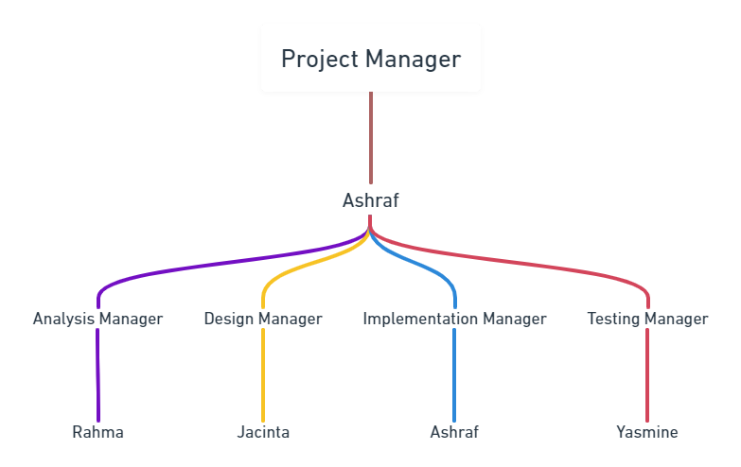

### 2.1.2 Roles and Responsibilities

#### 2.1.2.1 Analysis Manager

* Ensure the continuity of service by providing the planning, leadership, and project coordination necessary to implement new projects and optimize old ones.
* Track, resolve, and document root causes of user technical problems.
* Provide demos for product management.
* Develop and deliver operational reports and summaries of problems or technical difficulties.
* Prepare and present financial and economic models for the board of directors, managers, and investors.
* Assess infrastructure and platforms to judge feasibility and usefulness of available tools and resources.
* Comply with department methodologies and software development methodologies.
* Documenting interactions from the business owners.
* Identify and communicate project and design risks to the project manager.

#### 2.1.2.2 Design Manager

* Outlining how the design team will implement the required deliverables.
* Conducting regular meetings with the design team to ensure that the design process is on schedule, giving needed input and advice as well as building motivation.
* Coming up with effective design solutions and making the necessary decisions.
* Presenting to upper management the design strategy.
* Overseeing that all design documents are produced on time and to a high standard.

#### 2.1.2.1 Implementation Manager

* Draft an implementation strategy to ensure the new system is right for the company's goals.
* Introduce the technologies that will help in the development of the project.
* Delegate tasks properly; Senior programmers should take on difficult parts of the project that require a high level of problem solving skill, while junior programmers can take on easier parts of the project.
* Monitor the system throughout different stages to ensure the functions that were required are met, and later on suggests to the project manager/project board potential improvements for future versions of the project.

#### 2.1.2.1 Testing Manager

* The primary responsibility is to define the test strategy and coordinate the activities from the beginning till the end.
* Make a detailed plan to define the matrix which checks the progress of the task which is called test plan.
* Controlling the team budget, deadline and activities within the team.
* Make the test summary reports towards the end of any project
* Responsible for design test environment and also the configuration management, he will keep track of all the versions of the software’s and tools used for the testing.

#### 

# SECTION 3. TECHNICAL PROCESS

## 3.1 Methods, Tools and Techniques

### 3.1.1 Methods

|  |  |  |
| --- | --- | --- |
| Type of Methodology | Methodology Used | Justification |
| Software Project Management (SPM) | Stepwise Approach | Stepwise is the most suited one to use in planning this project, as it is known for its practicality; the steps of this approach are clear and concise. Also, it is scalable; it can work on big projects as well as small ones, and the TBS is currently a small project, so it will be practical for it. Finally, this approach is chosen due to elimination of other approaches; The PMBOK approach isn’t a concise methodology, but rather a set of guidelines which should be followed, but for a well understood project like the TBS, clear instructions of what to do next should be given instead of guidelines. The PRINCE2 methodology also is not recommended, as it requires a lot of documents which will increase the project’s timeline, and the TBS project has a very tight deadline schedule. |
| Software Development (SDM) | Waterfall Methodology | Since the TBS website will be initially small, and its details are fleshed out from the start, it is not likely that there will be changes as the project proceeds which also means a need for iteration is not likely. This makes waterfall methodology a good candidate for this project. |

### 3.1.2 Tools and Techniques

#### 3.1.2.1 Tools

For logo design: Krita and graphicsprings

For team communication: Zoom

For discussing project details: Google docs

For visualizing management details (e.g. Team Organizational Structure): Whimsical

#### 3.1.2.1 Techniques

The project was done as a website instead of an executable program, as it is more accessible to the user if they can enter from different devices (PC, mobile, etc) to get the same feature. Also, the project functionalities are simple enough to be implemented on a website.

Client-side scripting languages: HTML5, CSS, Javascript

Server-side programming languages: PHP, SQL

# SECTION 4. TECHNICAL PROCESS

## 4.1 Project Infrastructure

* Hardware: The website doesn’t have any complex functionalities or exorbitant design, so it can run with low-end devices (e.g on pc: 2gb RAM, dual core processor, etc).
* Operating Systems: compatible with all the systems (Windows, MAC, Linux), as this is a website, not an application.
* Intended network that the website will run on: Wide Area Network (WAN).

# 

# SECTION 5. MANAGEMENT PROCESS

## 5.1 Start Up

### 5.1.1 Estimation

Reference Tables for Size Estimation:

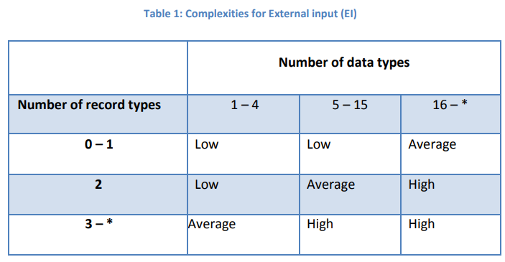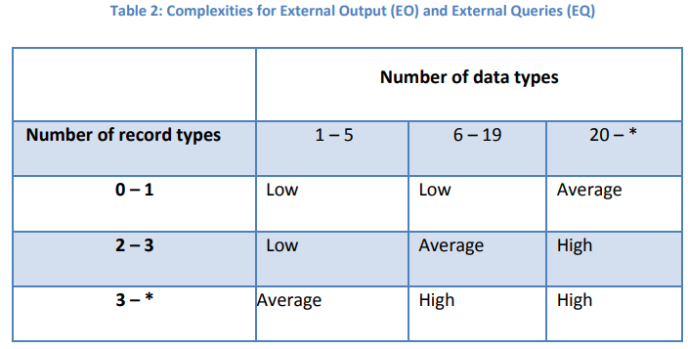

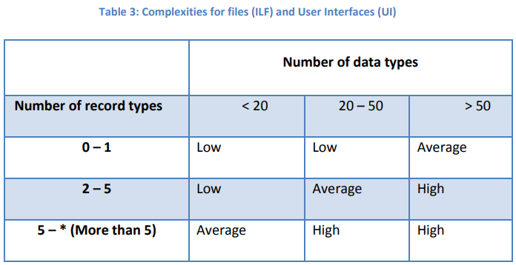

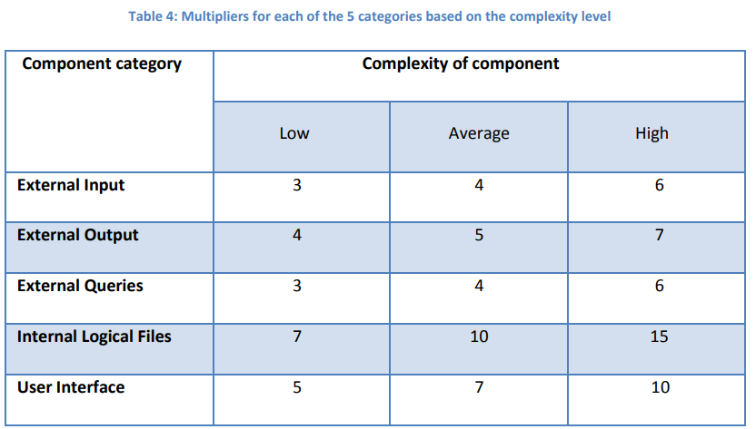

record types → num of tables

data types → num of components (table columns)

Reference Tables for Effort Estimation:

COCOMO 81:



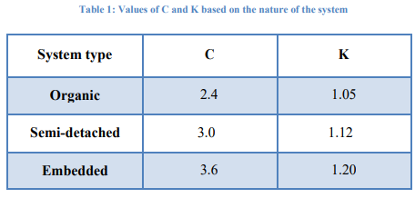

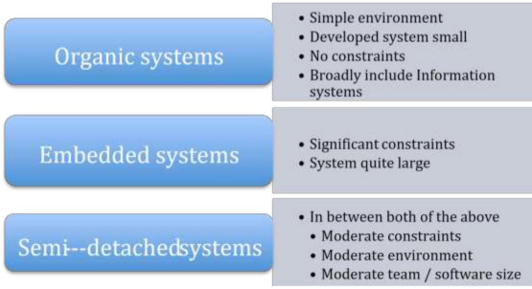

COCOMO II:









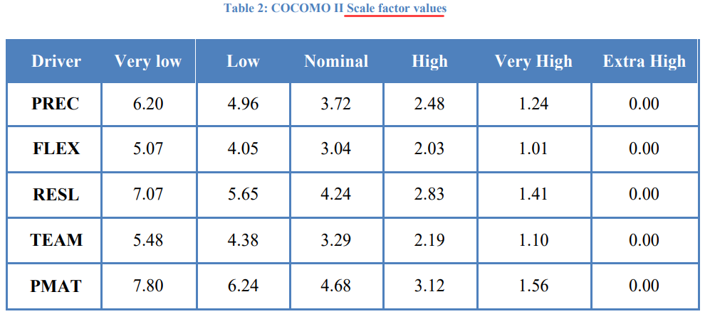

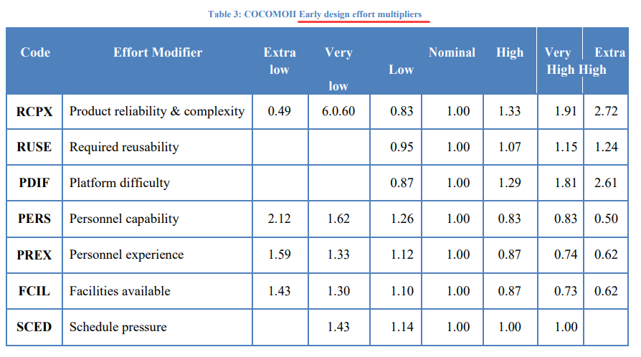

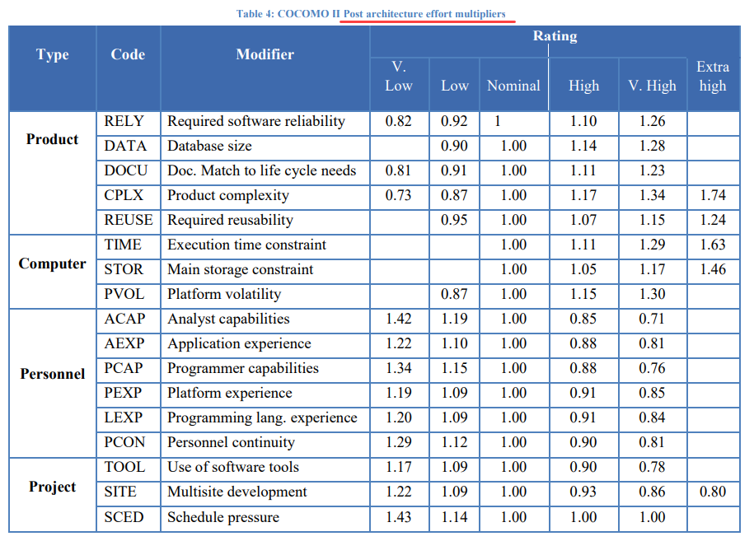

#### 5.1.1.1 Function Quiz (Jacinta)

After the user signs up, they will immediately be redirected to the quiz page. This quiz will be used to acquire crucial information about the patient.

The first part of the quiz consists of generic questions in order to learn about the user’s demographic. This will include their birthdate (for their age), their gender, income status, and reason for therapy (can check multiple reasons).

The second part of the quiz, which is the majority of the quiz, consists of multiple choice questions that aim to understand what issues the user has been facing, how long they have been experiencing these things, and to determine a general area of the user’s problem (the quiz screens for a variety of mental health issues such as depression, anxiety, PTSD, eating disorders, and more). This is in order to direct them to a suitable therapist and for their future therapist to get an idea of why the patient is coming to therapy.

These questions are answered from a scale of 1-5 and include the topics mood and depression, restlessness, sleep habits, eating habits and appetite, energy and productivity, self-esteem, concentration, suicidal ideation, anxiety and phobias, and physical health.

From the preliminary section of the quiz (demographics), this information is inserted into the User table of the database.

From the main section of the quiz (psychological screening), the answers are saved into the Quiz table of the database, along with the user’s ID to tie the results to the user’s account.

##### 5.1.1.1.1 Size Estimation (FP Technique)

*Count of Components*:

|  |  |  |
| --- | --- | --- |
| Component Type | Count | Component Name |
| External Input Types (EI) | 14 | 1. Age 2. Gender 3. Income 4. TherapyReasons 5. DepressionAnswer 6. RestlessnessAnswer 7. SleepAnswer 8. AppetiteAnser 9. EnergyAnswer 10. SelfEsteemAnswer 11. ConcentrationAnswer 12. SuicideAnswer 13. AnxietyAnswer 14. PhysicalHealthAnswer |
| External Output Types (EO) | 2 | 1. Error message in case any question is left unanswered 2. Message to show that quiz answers have been saved and that a list relevant therapist is being generated |
| External Inquiry Types (EQ) | 2 | 1. Insert query for quiz results 2. Insert query for user information |
| Logical Internal File Types (LIF) | 2 | 1. Quiz table 2. User table |
| External Interface File Types (EIF) | 0 |  |

*Identifying Data Types, Record Types and Complexity*:

|  |  |  |  |
| --- | --- | --- | --- |
| Component Type | Data Types | Record Types | Complexity |
| EI | 14 data types: Age, Gender, Income, TherapyReasons, DepressionAnswer, RestlessnessAnswer, SleepAnswer, AppetiteAnser, EnergyAnswer, SelfEsteemAnswer, ConcentrationAnswer, SuicideAnswer, AnxietyAnswer, PhysicalHealthAnswer | 2 record types: Quiz table, User table | Average |
| EO | 2 data types: error message, quiz complete message | 2 record types: Quiz table, User table | Low |
| EQ | 15 data types: UserID, Age, Gender, Income, TherapyReasons, DepressionAnswer, RestlessnessAnswer, SleepAnswer, AppetiteAnser, EnergyAnswer, SelfEsteemAnswer, ConcentrationAnswer, SuicideAnswer, AnxietyAnswer, PhysicalHealthAnswer | 2 record types: Quiz table, User table | Average |
| LIF | 15 data types: UserID, Age, Gender, Income, TherapyReasons, DepressionAnswer, RestlessnessAnswer, SleepAnswer, AppetiteAnser, EnergyAnswer, SelfEsteemAnswer, ConcentrationAnswer, SuicideAnswer, AnxietyAnswer, PhysicalHealthAnswer | 2 record types: Quiz table, User table | Low |
| EIF | 0 data types | 0 record types | Low |

*Size Estimation*:

(EI_datatypes * EI_complexity_multiplier) + (EO_datatypes * EO_complexity_multiplier) + (EQ_datatypes * EQ_complexity_multiplier) + (LIF_datatypes * LIF_complexity_multiplier) + (EIF_datatypes * EIF_complexity_multiplier)

= (14 * 4) + (2 * 4) + (15 * 4) + (15 * 7) + (0 * 5) = 229 FP

229 * 67 = 15343 LOC = 15.343 KLOC

Source for function point language table (php → 67): [cs.helsinki.fi](https://www.cs.helsinki.fi/u/taina/ohtu/fp.html#:~:text=70-,php,-67)

##### 5.1.1.1.2 Effort Estimation (COCOMO 81)

∵The novelty of this function is fairly high as the quiz has to be developed uniquely to meet the purposes of the website’s service, and has to accurately collect the required information about the patient, which may be difficult to determine. Psychological analysis experts may need to be outsourced to aid in the development of the second part of the quiz, thus bringing down team cohesion. Furthermore, since it is a one-time, fixed quiz, requirements are very unlikely to change.

∴ Function Type: Embedded

Effort = C(size)k

= 3.6 (15.343)1.20

= 95.366 PM

#### 5.1.1.2 Function View Therapist Details (Jacinta)

After the registered user has taken the quiz, a selection of therapists is displayed based on the patient’s answers to the quiz. This means that the user sees therapists that may be suitable and relevant to their needs, rather than seeing a list of every therapist available on the platform.

The user can also further filter these results by searching by name, choosing a preferred gender, or selecting a specific specialization.

Each therapist profile is displayed in a minimized fashion, which the user can then click on to expand for more detailed information.

In the minimized view, the user can see the therapist’s name, gender, and a brief list of their specializations.

In the drop-down view, the user will be able to also see the therapists background information and qualifications, a description of their specializations, their schedule of available times to book, and a button to book a session with this therapist.

The initial list of therapists shown to the user is determined by an algorithm that filters the results based on quiz answers, and retrieves the information about the therapists from the database by selecting from the Therapist table. These are then selected from again if the patient decides to further filter the results.

When looking at the expanded view, the therapist’s schedule is retrieved from the database from the Schedule table, which links the Therapist table (TherapistID, WorkDays, WorkHours) to the SessionLog table (Year, Month, Day, Time). The schedule table will hold information on the availability of the therapist, and every time a session is booked (from SessionLog), this information will be updated and this time slot will be blocked out from the therapist’s work days. Thus, the patient will see all the free times and will not be able to book at a time when the therapist already has a session or is unavailable (isBooked attribute).

##### 5.1.1.2.1 Size Estimation (Albrecht II FP Technique)

*Count of Components*:

|  |  |  |
| --- | --- | --- |
| Type Category | Count | Component Name |
| Inputs | 4 | 1. TherapistName 2. TherapistGender 3. Specialization 4. QuizID |
| Entities | 2 | 1. Therapist table 2. Schedule table |
| Outputs | 10 | 1. TherapistID 2. TherapistName 3. TherapistGender 4. Specialization 5. BackgroundInformation 6. SpecializationDescription 7. WorkDays 8. WorkHours 9. isBooked 10. Redirection to Book a Session page |

*Size Estimation*:

𝐹𝑝 𝑐𝑜𝑢𝑛𝑡 = 𝑁i ∗ 0.58 + 𝑁e ∗ 1.66 + 𝑁o ∗ 0.26

= (4 ∗ 0.58) + (1 ∗ 1.66) + (10 ∗ 0.26)

= 6.58 FP

= 6.58 * 67 LOC

= 440.86 LOC ≃ 441 LOC

= 0.441 KLOC

Source for function point language table (php → 67): [cs.helsinki.fi](https://www.cs.helsinki.fi/u/taina/ohtu/fp.html#:~:text=70-,php,-67)

##### 5.1.1.2.2 Effort Estimation (COCOMO II)

Scale Factor Values:

|  |  |  |  |
| --- | --- | --- | --- |
| Driver | Rating | Value | Justification |
| PREC | Very High | 1.24 | The implementation of the quiz itself is well-known and lacks uniqueness, however formulating the questions (especially the ones for psychological analysis) and the development of the algorithm (that uses the answers to filter therapist results) requires considerable innovation. |
| FLEX | Low | 4.05 | The function needs to achieve a specific and sensitive task, making the flexibility of implementation reduced. |
| RESL | Nominal | 4.24 | There is not much ambiguity as the requirements are pretty fixed, however the method on which to develop the results algorithm may cause some slight uncertainty. The accuracy of the quiz to determine the psychological state of the user may also be hard to measure. |
| TEAM | Low | 4.38 | As many different specialists may be required, some parts of the team may not be familiar with one another and may not be in close proximity to each other, which will lower the overall team cohesion. |
| PMAT | High | 3.12 | Since the requirements are thoroughly specified and understandable, the team should find themselves well organized. |

Early Design Effort Multipliers:

|  |  |  |  |
| --- | --- | --- | --- |
| Code | Rating | Value | Justification |
| RCPX | Very High | 1.91 | The function is quite complex due to the sorting and filtering algorithm being developed. A fair amount of data will be collected and stored (the user’s answers as well as the algorithmic result). It is also very important for this function to be reliable, as it is the first feature the user uses, and will determine the rest of their future experience/interaction on the website. |
| RUSE | Low | 0.95 | The application of this quiz on other projects will be unlikely, since it is specifically tailored to the services of this website. |
| PDIF | Nominal | 1.00 | There aren’t strict constraints as to the data storage or time required. Since the quiz takes place on web, the platform is the hardware, OS, network and distributed information repositories. |
| PERS | Nominal | 1.00 | The team may face some difficulty during design, however they are able to thoroughly communicate and are diligent in their work. The turnover rate is around 15% annually. |
| PREX | High | 0.87 | The team is very proficient in the programming language used, as well as various platforms. They can skillfully implement the quiz function, but the algorithm design may be a little more complex and require extra effort. |
| FCIL | High | 0.87 | Mature life cycle tools are provided for the team. Some personnel may not be collocated with the main team, but advanced communication support is provided in cases of outsourced specialists. |
| SCED | Low | 1.14 | A flexible deadline is imposed for the completion of this function. |

sf = B + 0.01 * ⅀(exponent driver ratings)

= 0.91 + 0.01 * (1.24 + 4.05 + 4.24 + 4.38 + 3.12)

= 1.0803

Product of exponent multipliers =

1.91 * 0.95 * 1.00 * 1.00 * 0.87 * 0.87 * 1.14

= 1.566

Effort = A (Size)sf x (Product of exponent multipliers)

= A (Size)B+0.01 * ⅀(exponent driver ratings) x ∏ exp. mult.

= 2.94 (0.441)1.0803 * 1.566

= 1.901 PM

#### 5.1.1.3 Function Therapist Dashboard (Ashraf)

When the therapist needs to check information regarding their clients (users), they refer to their dashboard page.

The dashboard page provides to the therapist a calendar stating all the upcoming sessions with the user name and exact time of the session - retrieved from the SessionLog and User tables with BookedSession as the junction table - that is displayed only when he hovers on a specific day on that calendar, where this day is also in the SessionLog table.

The aforementioned calendar displays only the current month, if the therapist wants to change the current month, he/she presses on the right and left arrows near the calendar that displays the next and previous month respectively.

Also regarding the calendar, each day could either be highlighted in a color if there’s a session with a user that day, or it could be not colored at all if there are no sessions that day, where this coloring is based on checking the date attribute in SessionLog table.

Aside from the calendar, the dashboard also displays all the users that have booked a session with that therapist, where each user is in one of two drop down elements: users that have attended at least one session with the therapist, and users who haven’t attended any sessions with the therapist. If the therapist clicks on a user in the former list, the therapist will be redirected to the session log page of that specific user. Otherwise, the results of the quiz that the user has taken when he/she first visited the site will be displayed to the therapist.

Also regarding the booked users, the therapist can directly find a specific user with the time of the next session by typing his/her name in the search bar provided above the two drop down elements. The therapist can also find multiple users who are booked on a specific day by clicking on that day in the calendar.

When specifying the scenario with respect to the database, there will be a Select Query for all the usernames that have booked a session with the therapist that is currently using the dashboard. This is done by connecting the TherapistID with the UserID that uses BookedSession Table. This query will also have a condition if the therapist has provided info (user name in search bar or day clicked on calendar) to filter the users that will be displayed on the page.

Also, the website’s backend will need an attribute that specifies for each user if he has had any previous sessions with that therapist or not, so that the users are placed under the correct headers. This is done using the AttendedBefore attribute in the BookedSession Table.

##### 5.1.1.3.1 Size Estimation (FP Technique)

*Count of Components*:

|  |  |  |
| --- | --- | --- |
| Component Type | Count | Component Name |
| External Input Types (EI) | 2 | 1. User Name 2. Day (of Booked Session(s)) |
| External Output Types (EO) | 6 | 1. Dashboard Page Elements (where the AttendedBefore Attribute of each user will decide the header that he/she will belong to) 2. User Name(s) of Booked Users 3. Day (of Booked Sessions) 4. Month (of Booked Sessions) 5. Year (of Booked Sessions) 6. Time (of Booked Sessions) |
| External Inquiry Types (EQ) | 3 | 1. Select Query for all the usernames 2. Select Query for the AttendedBefore Attribute of each user. |
| Logical Internal File Types (LIF) | 2 | 1. User Table 2. SessionLog Table |
| External Interface File Types (EIF) | 0 |  |

*Identifying Data Types, Record Types and Complexity*:

|  |  |  |  |
| --- | --- | --- | --- |
| Component Type | Data Types | Record Types | Complexity |
| EI | 2 data types:  User Name, Day | 2 record types:  User, SessionLog tables | Low |
| EO | 6 data types:  AttendedBefore, User Name, Day, Month, Year, Time | 2 record types:  User, SessionLog tables | Average |
| EQ | 8 data types:  UserID, TherapistID, AttendedBefore, User Name, Day, Month, Year, Time | 3 record types:  User, BookedSession, SessionLog | Average |
| LIF | 8 data types:  UserID, TherapistID, AttendedBefore, User Name, Day, Month, Year, Time | 3 record types:  User, BookedSession, SessionLog | Low |
| EIF | 0 data types | 0 record types | Low |

*Size Estimation*:

(EI_datatypes * EI_complexity_multiplier) + (EO_datatypes * EO_complexity_multiplier) + (EQ_datatypes * EQ_complexity_multiplier) + (LIF_datatypes * LIF_complexity_multiplier) + (EIF_datatypes * EIF_complexity_multiplier)

= (2 * 3) + (6 * 5) + (8 * 4) + (8 * 7) + (0 * 5)

124 FP = 124 * 67 = 8308 LOC = 8.308 KLOC

Source for function point language table (php → 67): [cs.helsinki.fi](https://www.cs.helsinki.fi/u/taina/ohtu/fp.html#:~:text=70-,php,-67)

##### 5.1.1.3.2 Effort Estimation (COCOMO 81)

∵ This is the first time the company deals with data regarding a therapist, efforts will be made to know the most relevant info that the therapist wants displayed in their dashboard making this function quite novel. In addition, since the page’s output is based on the therapist’s requirements, it might be changed frequently which leads to a drop in the function’s risk resolution. However, The development team has worked with each other in many previous projects, so cohesion for the function being implemented should be high.

∴ Function Type: Semi-Detached

Effort = C(size)k

= 3(8.308)1.12

= 32.13 PM

#### 5.1.1.4 Function Book A Session (Ashraf)

After choosing a therapist, the user then proceeds to the booking page where he/she can specify the day and the time of the booked session, given that it is a workday for the therapist.

He can also choose whether it is online or face-to-face.

The user can choose the payment method (credit or cash).

When the user clicks on the “confirm” button, then he/she will be redirected to the payment/confirmation page.

All of the aforementioned info will be inserted in the database in the SessionLog table given that he/she chooses a day that is a workday for the therapist.

The actual time of insertion of the record in the SessionLog table will vary according to the following scenarios:

1. If the user has chosen to pay by cash, then the record will be instantly inserted and the PaymentMethod attribute will be “Cash”.
2. Otherwise, the record will be inserted once the credit card has been validated (which is dealt by “function payment”), and the PaymentMethod attribute will be “Credit”.

In the event that the record has been successfully inserted, the UserID and TherapistID (from User and Therapist tables) will be put together in a record for the junction table BookedSession, and also in that record will be the SessionLogID that points to the aforementioned inserted record in the SessionLog Table.

##### 5.1.1.4.1 Size Estimation (Albrecht II FP Technique)

*Count of Components*:

|  |  |  |
| --- | --- | --- |
| Type Category | Count | Component Name |
| Inputs | 5 | 1. TherapistID, as the user has selected the therapist by clicking on him/her in the view therapists page. 2. Day (of Booked Session) 3. Time (of Booked Session) 4. SessionType; Online or Face to Face 5. PaymentMethod; Cash or Credit |
| Entities | 4 | 1. User Table 2. Therapist Table 3. BookedSession Table 4. SessionLog Table |
| Outputs | 1 | 1. Payment page (in which the “function payment” will decide based on the PaymentMethod Attribute if the payment page will just be a confirmation message or a payment by credit page). |

*Size Estimation*:

𝐹𝑝 𝑐𝑜𝑢𝑛𝑡 = 𝑁i ∗ 0.58 + 𝑁e ∗ 1.66 + 𝑁o ∗ 0.26

= 5 ∗ 0.58 + 4 ∗ 1.66 + 1 ∗ 0.26

= 9.8 FP

= 9.8 * 67 LOC

= 656.6 ≃ 657 LOC

= 0.657 KLOC

Source for function point language table (php → 67): [cs.helsinki.fi](https://www.cs.helsinki.fi/u/taina/ohtu/fp.html#:~:text=70-,php,-67)

##### 5.1.1.4.2 Effort Estimation (COCOMO II)

Scale Factor Values:

|  |  |  |  |
| --- | --- | --- | --- |
| Driver | Rating | Value | Justification |
| PREC | Low | 4.96 | The development team has experience on booking functions from previous projects. However, they haven’t dealt with therapy sessions, so the inputs and their logic (validity of entered day, etc) are new to the developers. |
| FLEX | Very Low | 5.07 | There are specific values that must be inserted no matter how the booking page looks, so workarounds for the function’s complexity are not feasible. |
| RESL | Very High | 1.41 | There is no ambiguity in the requirements, as the team knows exactly what is required for the user to enter when booking a session with their chosen therapist. |
| TEAM | Very High | 1.10 | The team has worked on many projects before, and they’re all stationed in neighboring offices, making their cohesion and collaboration very high. |
| PMAT | High | 3.12 | The project’s SRS is well structured, making the implementation of the function a straightforward task. |

Post Architecture Effort Multipliers:

|  |  |  |  |  |
| --- | --- | --- | --- | --- |
| Type | Code | Rating | Value | Justification |
| Product | RELY | Very High | 1.26 | Many users will use the booking functionality, so the team must ensure the function is executed as intended by minimizing bugs and risks of failure. |
| DATA | Very High | 1.28 | There will be a lot of data in the database concerning the user, the therapist, and the session details of every booked session made in the website, so it is expected to generate a lot of test data when performing unit tests. |
| DOCU | Nominal | 1.00 | An average amount of software documentation will be needed to cover the essential details about the database and function implementation, but not too much documentation due to the limited project’s scope. |
| CPLX | Nominal | 1.00 | The overall complexity of the function is expected to be nominal, as there are no computational operations, but some complex control operations (nested queries, multiple conditions are checked, etc). |
| REUSE | Very High | 1.15 | Since the team expects to reuse a booking function in future projects, the function will have to be elegantly documented and extensively tested. |
| Computer | TIME | Nominal | 1.00 | No specific constraints have been asked regarding the maximum time to finish executing the booking function. |
| STOR | Nominal | 1.00 | No specific constraints have been asked regarding the data storage that the booking function deals with. |
| PVOL | Very High | 1.30 | The project is a website that is expected to work on multiple platforms, thus the platform is the network, computer hardware, the operating system, and the distributed information repositories. |
| Personnel | ACAP | High | 0.85 | Our team is capable of designing the function in different levels; from high-level conceptual design to miniscule design details. |
| AEXP | High | 0.88 | Our team has dealt with booking functions for the past 3 years. |
| PCAP | Very High | 0.76 | Our team is highly cooperative, cohesive and thorough, so swift communication to deal with the function’s logic and implementation is guaranteed. |
| PEXP | High | 0.88 | Our team has dealt with projects implemented on various platforms, GUIs, and DBMSs, so knowledge about how the function will be implemented in these aspects is present. |
| LEXP | High | 0.91 | Our team has used various programming languages and software tools throughout the past 3 years, so converting the function’s logic to code shouldn’t be a problem. |
| PCON | Nominal | 1.00 | Around a tenth of our personnel is changed every year, so the people responsible for the function’s logic are not likely to change soon. |
| Project | TOOL | Nominal | 1.00 | Sufficient tools (frontend, backend, etc) have been decided for this project, no extra CASE tools will be included, so the team knows the needed tools for implementing the function. |
| SITE | Extra High | 0.80 | The team is located in the same building with neighboring offices and conferences are being held on a daily basis to ensure perfect, swift, and easy communication methods while discussing the function’s logic and implementation. |
| SCED | Nominal | 1.00 | No strict deadlines have been enforced, therefore the team doesn’t have to worry too much about the project’s schedule while implementing the function. |

sf = B + 0.01 * ⅀(exponent driver ratings)

= 0.91 + 0.01 * (4.96 + 5.07 + 1.41 + 1.10 + 3.12)

= 1.0666

Product of exponent multipliers =

1.26 x 1.28 x 1 x 1 x 1.15 x 1 x 1 x 1.3 x 0.85 x 0.88 x 0.76 x 0.88 x 0.91 x 1 x 1 x 0.80 x 1

= 0.878

Effort = A (Size)sf x (Product of exponent multipliers)

= A (Size)B+0.01 * ⅀(exponent driver ratings) x ∏ exp. mult.

= 2.94 (0.657)1.0666 x 0.878

= 1.649 PM

#### 5.1.1.5 Function Payment (Yasmine)

After the user confirms the booked session, he/she will be redirected to the payment/confirmation page.

The payment process depends on the payment method, the first option is cash which is the original and oldest payment method to pay on the date of the session. Finally the website displays a confirmation message for booking. the second option is the online payment to avoid pitfalls ,the user may choose debit/credit cards such as visa, meeza, or mastercard which support extra layer of security during payment process that ensures purchases are not fraudulent and come from a verified bank account. he/she have to input the CVV, card PIN code, the last three numbers of expiration date and the card's full name to complete the payment. the user receives an OTP (One Time Password ) SMS from the bank to make sure that transaction is from the owner of the card. the user enters the OTP message and clicks on "Verify card". Finally the system checks if the entire data is valid,the user will receive a confirmation email about the withdrawn money for the session, and the current balance of the card. if it is not valid the system displays an error message.

##### 5.1.1.5.1 Size Estimation (FP Technique)

*Count of Components*:

|  |  |  |
| --- | --- | --- |
| Component Type | Count | Component Name |
| External Input Types (EI) | 5 | 1. Card PIN code 2. full name 3. CVV 4. last three numbers of expiration date full name 5. OTP |
| External Output Types (EO) | 2 | 1. Error message if the entire data is invalid or there is a missed data 2. confirmation email about the withdrawn money for the session |
| External Inquiry Types (EQ) | 2 | 1. insert query for user payment method details 2. select query for checking the input data of the card |
| Logical Internal File Types (LIF) | 2 | 1. Payment method table 2. User table |
| External Interface File Types (EIF) | 1 | 1. User table (bank database) |

*Identifying Data Types, Record Types and Complexity*:

|  |  |  |  |
| --- | --- | --- | --- |
| Component Type | Data Types | Record Types | Complexity |
| EI | 6 data types:  UserID, card PINcode, full name, CVV, last three numbers of expiration date, full name, OTP | 2 record types:  User, PaymentMethod tables | Average |
| EO | 2 data types:  error message and confirmation mail | 2 record types:  User, PaymentMethod tables | Low |
| EQ | 7 data types:  userID, card PINcode, full name, CVV, last three numbers of expiration date, full name, OTP | 2 record types:  User, PaymentMethod tables | Average |
| LIF | 6 data types:  userID, card PINcode, full name, CVV, last three numbers of expiration date, full name, OTP | 3 record types:  User, BookedSession, SessionLog | Average |
| EIF | 5 data types:  userID, SSN, Full name, Address, Account number | 1 record type:  User table (Bank databases) | Low |

*Size Estimation*:

(EI_datatypes * EI_complexity_multiplier) + (EO_datatypes * EO_complexity_multiplier) + (EQ_datatypes * EQ_complexity_multiplier) + (LIF_datatypes * LIF_complexity_multiplier) + (EIF_datatypes * EIF_complexity_multiplier) = (6*4)+(2*4)+(6*4)+(6*10)+(5*5) = 141 FP

141 * 67 = 9447 LOC = 9.447 KLOC

Source for function point language table (php → 67): [cs.helsinki.fi](https://www.cs.helsinki.fi/u/taina/ohtu/fp.html#:~:text=70-,php,-67)

5.1.1.5.2 Effort Estimation (COCOMO 81)

∵The novelty of this function is fairly high as the payment has to be developed uniquely to complete the booking of the session, and has to accurately collect the required information from the user depending on the method of the payment.

∴ Function Type: Embedded

Effort = 3.6(9.447)1.20

= 53.29 PM

#### 5.1.1.6 Function Session Log (Yasmine)

from the therapist dashboard, he clicks on 'users who have booked' then he transfers to the 'session log' page. The page contains the details of the patient and the interaction between the patient and the therapist. The interaction occurs through the chat box which is available only for patients who attend at least one session. Also the therapist is able to view answers on the initial quiz of the patients who are just booked. These results give the therapist feedback about the patient's mental state. After the patient has attended the first session, the therapist inserts a new document. Also, he may modify or delete documents of patients that already complete their treatment. Each patient document includes the disorder type, last session description, the mental state, syndromes, number of sessions taken, date of upcoming sessions and personal information like origin, relatives.

##### 5.1.1.6.1 Size Estimation (Albrecht II FP Technique)

*Count of Components*:

|  |  |  |
| --- | --- | --- |
| Type Category | Count | Component Name |
| Inputs | 7 | 1. disorder type  2. last session description  3. mental state  4. syndromes  5. number of sessions taken  6. date of upcoming sessions  7. relatives |
| Entities | 2 | 1. user table  2. Booked session |
| Outputs | 1 | 1. Document for each patient |

*Size Estimation*:

𝐹𝑝 𝑐𝑜𝑢𝑛𝑡 = 𝑁i ∗ 0.58 + 𝑁e ∗ 1.66 + 𝑁o ∗ 0.26

= 7*0.58+2*1.66+1*0.26 = 7.64 FP

= 7.64 * 67 = 511.88 LOC

= 0.51188 KLOC

Source for function point language table (php → 67): [cs.helsinki.fi](https://www.cs.helsinki.fi/u/taina/ohtu/fp.html#:~:text=70-,php,-67)

##### 5.1.1.6.2 Effort Estimation (COCOMO II)

Scale Factor Values:

|  |  |  |  |
| --- | --- | --- | --- |
| Driver | Rating | Value | Justification |
| PREC | Low | 4.96 | from the previous project, the testing team faced various of function types however this type of therapy project especially the session log function that depends on inserting sensitive and private information for each patient which need that each tester should have a great deal of honesty. |
| FLEX | Very Low | 5.07 | in terms of the number of available ways there are specific and limited ways to meet the requirements of the page, so it may not flexible and has high rating. |
| RESL | Very High | 1.41 | the requirements is clear and has no ambiguity, as the team knows what should the therapist insert in the document foe each patient. |
| TEAM | Low | 4.05 | Although the high collaboration and cohesion of the team, the newly covid 19 affected on working offline. Therefore, most of their meetings were online |
| PMAT | High | 3.12 | the testing of the function is straightforward, well designed and well structured. |

Post Architecture Effort Multipliers:

|  |  |  |  |  |
| --- | --- | --- | --- | --- |
| Type | Code | Rating | Value | Justification |
| Product | RELY | Very High | 1.26 | Many therapists will use the session log function to document the patient info, so the team makes sure that the function is totally tested. |
| DATA | Very High | 1.28 | generating a lot of unit testing because of the expected large data in the database concerning the patient details for each session made on the website. |
| DOCU | High | 1.11 | the high documentation of the software will be needed to cover all patient information in the database and function testing. |
| CPLX | Nominal | 1.00 | the complexity of the function is expected to be nominal, as the function just depends on well-structured patient documents creation. |
| REUSE | Low | 0.95 | it is expected that the team do not reuse the session log function in other project because the project is very unique and may be not repeated at all. |
| Computer | TIME | Nominal | 1.00 | No specific constraints have been asked regarding the maximum time to finish executing the session log function. |
| STOR | High | 1.05 | There are some specific constraints regarding the data storage that the session log function deals with due to the large needed database. |
| PVOL | Very High | 1.30 | The project is a website that is expected to work on multiple platforms, thus the platform is the network, computer hardware, the operating system, and the distributed information repositories. |
| Personnel | ACAP | High | 0.85 | Our team is capable of designing the function in different levels; from high-level conceptual design to miniscule design details. |
| AEXP | Very Low | 1.22 | Our team may not deal with session log functions in other project. |
| PCAP | Very High | 0.76 | Our team is highly cooperative, cohesive and thorough, so swift communication to deal with the function’s logic and testing is guaranteed. |
| PEXP | High | 0.88 | Our team has dealt with projects implemented on various platforms, GUIs, and DBMSs, so knowledge about how the function will be implemented in these aspects is present. |
| LEXP | High | 0.91 | Our team has used various programming languages and software tools throughout the past 3 years, so converting the function’s logic to code shouldn’t be a problem. |
| PCON | Nominal | 1.00 | Around a tenth of our personnel is changed every year, so the people responsible for the function’s logic are not likely to change soon. |
| Project | TOOL | Nominal | 1.00 | Sufficient tools testing tools have been decided for this project, no extra CASE tools will be included, so the team knows the needed tools for testing the function. |
| SITE | Extra High | 0.80 | The team is located in the same building with neighboring offices and conferences are being held on a daily basis to ensure perfect, swift, and easy communication methods while discussing the function’s logic and testing. |
| SCED | Nominal | 1.00 | No strict deadlines have been enforced; therefore the team doesn’t have to worry too much about the project’s schedule while implementing the function. |

sf = B + 0.01 * ⅀(exponent driver ratings)

= 0.91 + 0.01 * (4.96 + 5.07+ 1.41 + 4.05 + 3.12)

= 1.0961

Product of exponent multipliers = 1.26*1.28*1.11*1*0.95*1*1.05*1.30*0.85*1.22*0.76*0.88*0.91*1*1*0.80*1=1.172104

Effort = A (Size)sf x (Product of exponent multipliers)

= A (Size)B+0.01 * ⅀(exponent driver ratings) x ∏ exp. mult.

= 2.94 (0.51188) 1.0961*1.172104

= 1.6539 PM

#### 5.1.1.7 Function Add Therapist (Rahma)

After each therapist signs up and attaches all the proofs and certificates, which will be directed to the admin, the admin will have the authority to add a new therapist, but he must check his certificate, contact the last place the therapist was working at or read the recommendation letter if he is a fresh graduate. If the therapist is all good, the admin will create him/her a profile and add it to the hierarchy according to their specialization, he must enter the therapist full name, ID, specialization, background information, gender, age, email, password, available working days in the system he will then send a mail to that therapist congratulating them “you are accepted, you can check your profile on the website (putting the link of their profile)”.

##### 5.1.1.7.1 Size Estimation (Albrecht II FP Technique)

*Count of Components*:

|  |  |  |
| --- | --- | --- |
| Type Category | Count | Component Name |
| Inputs | 10 | 1. Therapist Full Name  2. Therapist ID  3. Therapist Specialization  4. Therapist Background information  5. Therapist Gender  6. Therapist Age  7. Therapist Email  8. Therapist password  9. Therapist available workingDays  10. isbooked |
| Entities | 3 | 1. Therapist table  2. Schedule table  3. Booked sessions table |
| Outputs | 1 | Creation of the therapist profile |

*Size Estimation*:

𝐹𝑝 𝑐𝑜𝑢𝑛𝑡 = 10∗ 0.58 + 3 ∗ 1.66 + 1 ∗ 0.26

= 11.04 FP

= 11.04 * 67 = 739.68 LOC

= 0.73968 KLOC

Source for function point language table (php → 67): [cs.helsinki.fi](https://www.cs.helsinki.fi/u/taina/ohtu/fp.html#:~:text=70-,php,-67)

##### 5.1.1.7.2 Effort Estimation (COCOMO II)

Scale Factor Values:

|  |  |  |  |
| --- | --- | --- | --- |
| Driver | Rating | Value | Justification |
| PREC | Low | 4.96 | The function of add therapist is a basic function, and its implementation is known in other systems, doesn’t have a unique feature, that’s why it is not a complex function. |
| FLEX | Low | 4.05 | The function needs to accomplish a specific task with a specific way, that’s why the feasibility rating is low |
| RESL | High | 2.83 | The function add therapist is not ambiguous, as all the requirements needed to add a therapist is direct and critical, and the information of the therapist must be complete |
| TEAM | Low | 3.29 | Because we are in a crisis (covid-19), the team lacks cohesion as they must conduct most of the meetings online via zoom, Microsoft teams, skype. |
| PMAT | High | 3.1 | The function add therapist is organized and direct is not ambiguous |

Early Design Effort Multipliers:

|  |  |  |  |
| --- | --- | --- | --- |
| Code | Rating | Value | Justification |
| RCPX | Nominal | 1.00 | The function add therapist is not a complex function it is very basic and well known in other systems. |
| RUSE | Very high | 1.15 | The function add is very useful as it might be in other projects, and it can be reused in those projects but with some changes. |
| PDIF | Low | 0.87 | This function doesn’t have constricted constraints for the data storage or time and doesn’t have a platform difficulty as it is a back-end function not front end. |
| PERS | Very Low | 1.62 | The staff who are responsible for this function will not face any difficulties as its simple the turnover rate is 33% |
| PREX | Nominal | 1.00 | The team that is responsible for this function may be experienced and know how to code this function but because it’s a basic function that is used in many projects, they can use it from other projects with some changes to suit the project |
| FCIL | Extra low | 1.43 | As the team doesn’t need any additional tools, weak support of complex multi site development |
| SCED | High | 1.00 | The add function must be done in a certain amount of time, must be implemented within the deadline |

sf = B + 0.01 * ⅀(exponent driver ratings)

= 0.91 + 0.01 * (4.96 + 4.05 + 2.83 + 3.29 + 3.1)

= 1.0923

Product of exponent multipliers =

1.00 * 1.15 * 0.87 * 1.62 * 1.00 * 1.43 * 1.00

= 2.3177583

Effort = A (Size)sf x (Product of exponent multipliers)

= A (Size)B+0.01 * ⅀(exponent driver ratings) x ∏ exp. mult.

= 2.94 (0.73968) ^1.0923 * 2.3177583

= 4.901986391 PM

#### 5.1.1.8 Function Remove User/Therapist (Rahma)

If the therapist has the desire to deactivate his profile, he must direct contact the admin via mail, the admin then can remove the therapist’s profile by giving the therapist ID then the system will check if that therapist doesn’t have patients enrolling with him/her (no records of patients in the session log table) ;if yes, the system will send the therapist a confirmation mail saying, “Your profile has been deleted”, removing all the therapist information from all the tables related to the therapist table (therapist table, schedule table, booking table, session log table). If the therapist has documents for patients in the log session, then the records of the therapist will not be removed, unless all his/her patients enrol with another therapist; but the therapist that wants to remove his/her account will be inaccessible (cannot access his/her profile), and a notification will be sent to all the patients that they must enrol with another therapist; returning to the view therapist details function. A Report option will be set in the chat box in the session log that the therapist may report any vulgarity or rudeness from the patient; then the therapist can remove that patient from his session log; and the admin can remove that patient from the all the tables related to the patient (patient table, booked session table).

##### 5.1.1.8.1 Size Estimation (FP Technique)

*Count of Components*:

|  |  |  |
| --- | --- | --- |
| Component Type | Count | Component Name |
| External Input Types (EI) | 2 | 1. Therapist ID 2. Patient ID |
| External Output Types (EO) | 3 | 1. Remove Therapist record 2. Remove Patient record 3. View therapist details function |
| External Inquiry Types (EQ) | 1 | Delete query that either removes the therapist record or the patient record |
| Logical Internal File Types (LIF) | 5 | 1. If patient:    1. Booked sessions table    2. Patient table 2. If therapist:    1. Therapist table    2. SessionLog    3. Schedule table    4. Booked table |
| External Interface File Types (EIF) | 0 |  |

*Identifying Data Types, Record Types and Complexity*:

|  |  |  |  |
| --- | --- | --- | --- |
| Component Type | Data Types | Record Types | Complexity |
| EI | 2 datatypes:   * therapist ID * patient ID | 2 record types:   * therapist table * patient table | Low |
| EO | 3 data types:   * Remove therapist records * Remove patient records | 5 record types:  1. If therapist:   * Therapist table * SessionLog table * Schedule table * Booked Session table   2. If patient:   * Patient table * Booked Session table | Average |
| EQ | 24 data type:  1. From Therapist table:   * Therapist ID * Therapist Full Name * Therapist Background information * Therapist specialization * Therapist gender * Therapist age * Therapist E-mail * Therapist password   2. From Schedule table:   * Therapist available working days * Therapist ID     3. From Patient table:   * Patient ID * Patient Full Name * Patient gender * Patient age * Patient diagnosis * Patient E-mail * Patient password   4. From Session Log table:   * Therapist ID * Patient ID * Disorder type * Mental state * Last session description * Syndrome * No. of session taken * Date of upcoming sessions * Relatives   5. From booked session:   * Therapist ID * Patient ID | 5 record types:  1. If therapist:   * Therapist table * SessionLog table * Schedule table * Booked Session table   2. If patient:   * Patient table * Booked Session table | High |
| LIF | 24data type:  1. From Therapist table:   * Therapist ID * Therapist Full Name * Therapist Background information * Therapist specialization * Therapist gender * Therapist age * Therapist E-mail * Therapist password   2. From Schedule table:   * Therapist available working days * Therapist ID   3. From Patient table:   * Patient ID * Patient Full Name * Patient gender * Patient age * Patient diagnosis * Patient E-mail * Patient password   4. From Session Log table:   * Therapist ID * Patient ID * Disorder type * Mental state * Last session description * Syndrome * No of session taken * Date of upcoming sessions * Relatives   5. From booked session:   * Therapist ID * Patient ID * Isbooked | 5 record types:  24 If therapist:   * Therapist table * SessionLog table * Schedule table * Booked Session table   25 If patient:   * Patient table * Booked Session table | Average |
| EIF | 0 data types: | 0 record types: | low |

*Size Estimation*:

(2* 3) + (3 *5) + (24* 6) + (24*10) + (0*5) = 405 FP

405 * 67 = 27135 LOC = 27.135 KLOC

Source for function point language table (php → 67): [cs.helsinki.fi](https://www.cs.helsinki.fi/u/taina/ohtu/fp.html#:~:text=70-,php,-67)

##### 5.1.1.8.2 Effort Estimation (COCOMO 81)

∵ This function is critical to the system but doesn’t have as many constraints, one of the few constraints is that we cannot remove a therapist that have enrolled patients with him/her, the therapist will not be able to access the account, the system will notify the patients that they must enrol with another therapist; calling the function view therapist details, when all the patients enrol with another therapist then the therapist will be removed completely from the system. Also, the function doesn’t need many team members because it is a pretty simple function.

∴ Function Type: semi-detached

Effort = C (size)k

= 3.0 (27.135)1.12

= 120.9691585 PM

#### 5.1.1.9 Function Verification(Rahma)

After the therapist signs up, a page will be displayed that the therapist can attach some requirements in order to be accepted and added on the website as a therapist; only if this data is authentic. The therapist must attach a certificate stamped by the government, CV and if he/she is a fresh graduate then, has to attach a recommendation letter from a qualified doctor in his/her major. If not then the therapist must fill in other requirements; the mail of the last employment place, phone number if available, and the therapist finally have to attach his/her resignation letter form the past employment. Afterwards a mail will be sent to the therapist saying that his/her information has been sent to the admin and will be notified as soon as the admin checks this Data.

##### 5.1.1.9.1 Size Estimation (Albrecht II FP Technique)

*Count of Components*:

|  |  |  |
| --- | --- | --- |
| Type Category | Count | Component Name |
| Inputs | 5 | 1. Certificate 2. CV 3. Recommendation letter (if fresh graduate) 4. The contact information of the last employment place (if not fresh graduate) 5. The reason of the resignation from the last employment place (if not fresh graduate) |
| Entities | 1 | Therapist table |
| Outputs | 1 | 1. Confirmation mail that the therapist   information has been sent to the admin and will be notified as soon as the admin checks this Data. |

*Size Estimation*:

𝐹𝑝 𝑐𝑜𝑢𝑛𝑡 = 5 ∗ 0.58 + 1∗ 1.66 + 1 ∗ 0.26

= 4.82 FP

= 4.82 * 67 = 322.94 LOC

= 0.32294 KLOC

Source for function point language table (php → 67): [cs.helsinki.fi](https://www.cs.helsinki.fi/u/taina/ohtu/fp.html#:~:text=70-,php,-67)

##### 5.1.1.9.2 Effort Estimation (COCOMO II)

Scale Factor Values:

|  |  |  |  |
| --- | --- | --- | --- |
| Driver | Rating | Value | Justification |
| PREC | Low | 4.96 | The implementation of the function Verification is not strange, it is very simple and is not unique |
| FLEX | Low | 4.05 | The function needs to accomplish a specific task with a specific way, that’s why the feasibility rating is low |
| RESL | High | 2.83 | The function Verification is not ambiguous, as all the requirements needed to add a therapist is direct and critical, that no therapist could be added on the website without these requirements |
| TEAM | Low | 3.29 | Because we are in a crisis (covid-19), the team lacks cohesion as they must conduct most of the meetings online via zoom, Microsoft teams, skype. |
| PMAT | High | 3.1 | The function Verification is organized and direct is not ambiguous, because the requirements needed from the therapist to be added are straightforward |

Early Design Effort Multipliers:

|  |  |  |  |
| --- | --- | --- | --- |
| Code | Rating | Value | Justification |
| RCPX | Nominal | 1.00 | The function Verification is not a complex function, it is very simple and well known in other systems. |
| RUSE | high | 1.07 | The function Verification might be in another job websites because this function verifies the employee’s identity |
| PDIF | Low | 0.87 | This function doesn’t have constricted constraints for the data storage or time and doesn’t have a platform difficulty as it is a back-end function not front end. |
| PERS | Extra Low | 2.12 | The staff who are responsible for this function will not face any difficulties as its simple the turnover rate is 45% |
| PREX | Extra low | 1.59 | The team of this function may be skilled, but this function is so simple that it doesn’t need a genius to code it. |
| FCIL | Extra low | 1.43 | As the team doesn’t need any additional tools, weak support of complex multi site development |
| SCED | High | 1.00 | The Verification function must be done in a certain amount of time, must be implemented within the deadline |

sf = B + 0.01 * ⅀(exponent driver ratings)

= 0.91 + 0.01 * (4.96 + 4.05 + 2.83 + 3.29 + 3.1)

= 1.0923

Product of exponent multipliers =

1.00 * 1.07 * 0.87 * 2.12 * 1.59 * 1.43 * 1.00

= 4.48716514

Effort = A (Size)sf x (Product of exponent multipliers)

= A (Size)B+0.01 * ⅀(exponent driver ratings) x ∏ exp. mult.

= 2.94 (0.32294)1.0923 x 4.48716514

= 3.83824922 PM

### 5.1.2 Work Activities

#### 5.1.2.1 Analysis Phase WBS (Rahma)

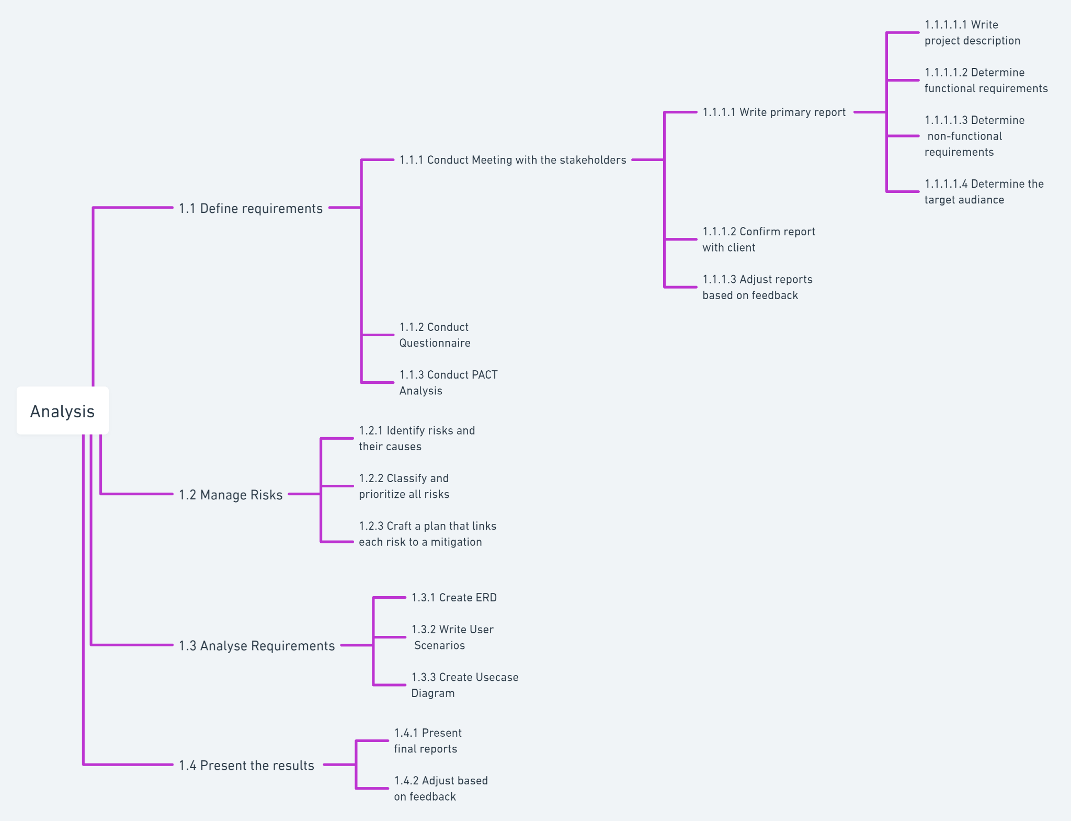

#### 5.1.2.2 Design Phase WBS (Jacinta)

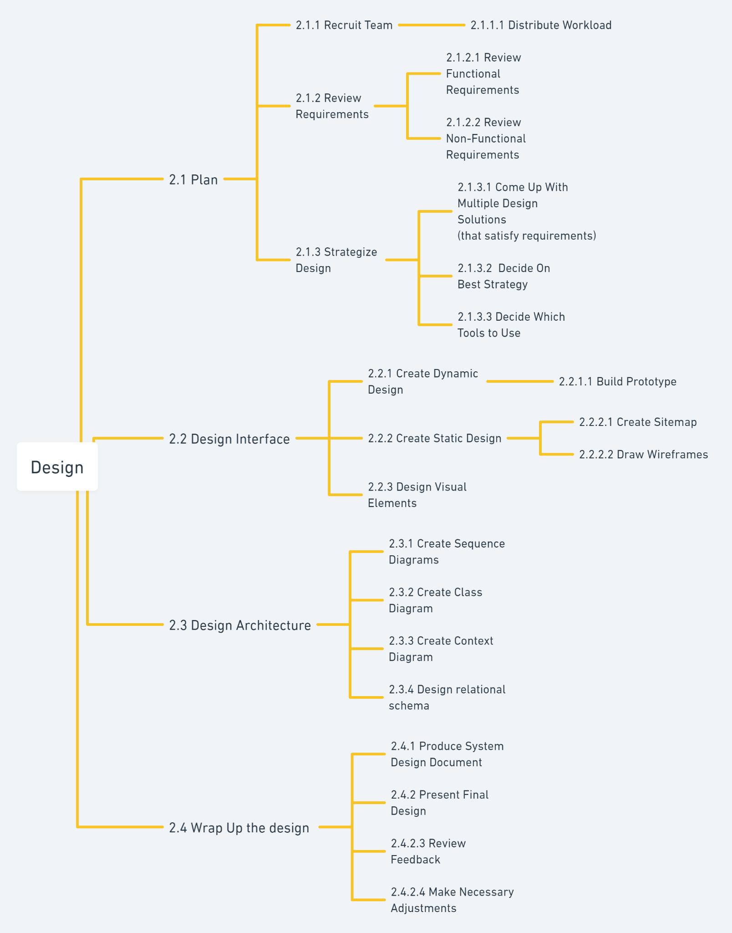

#### 5.1.2.3 Implementation Phase WBS (Ashraf)

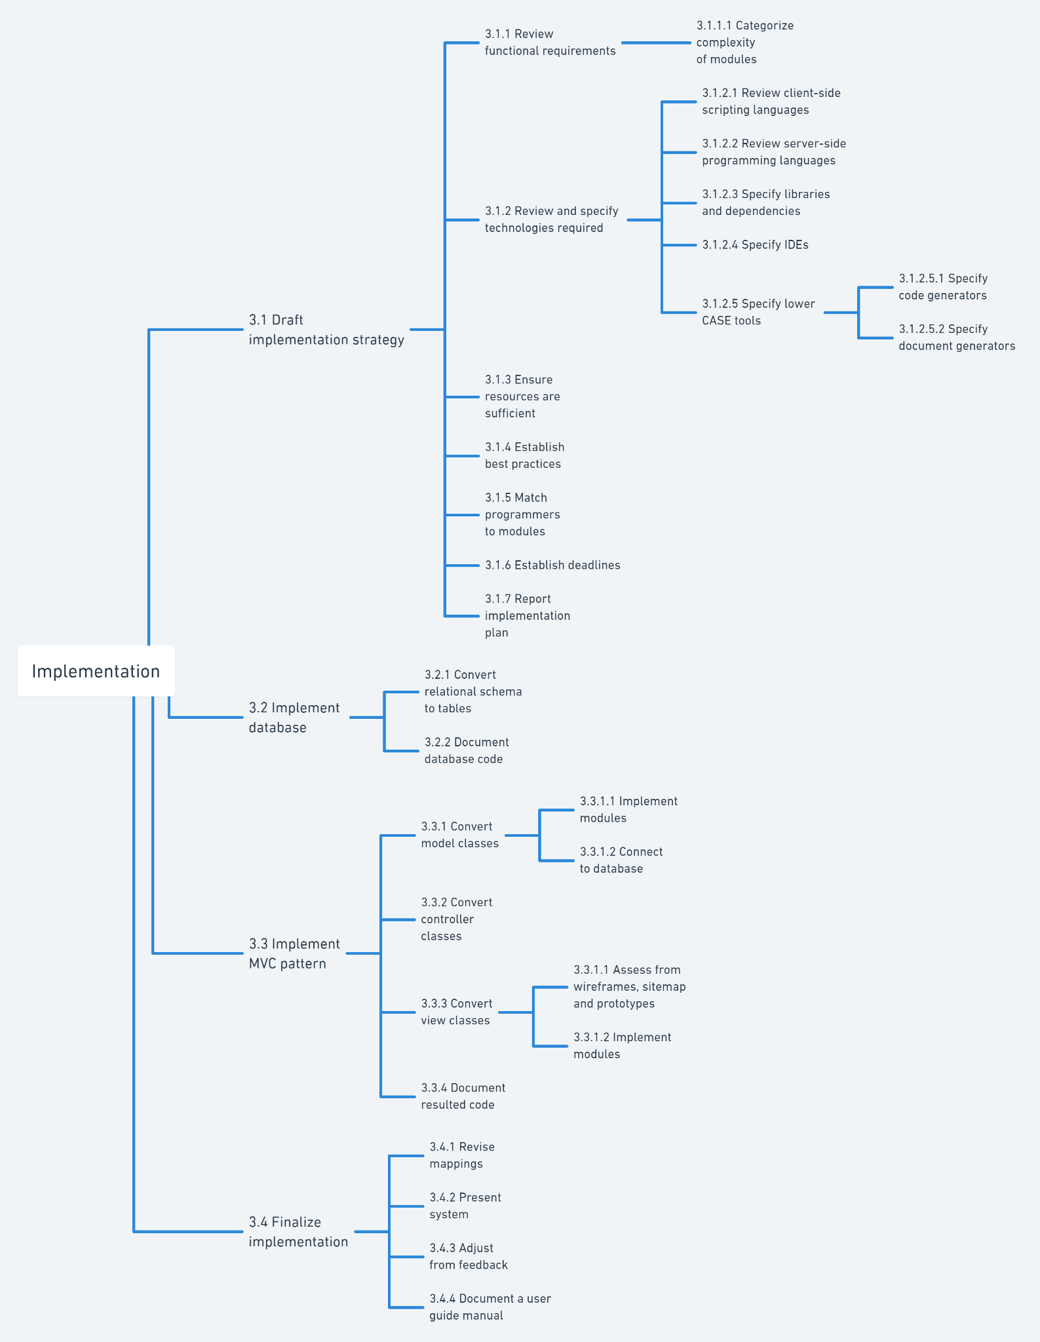

#### 5.1.2.4 Testing Phase WBS (Yasmine)

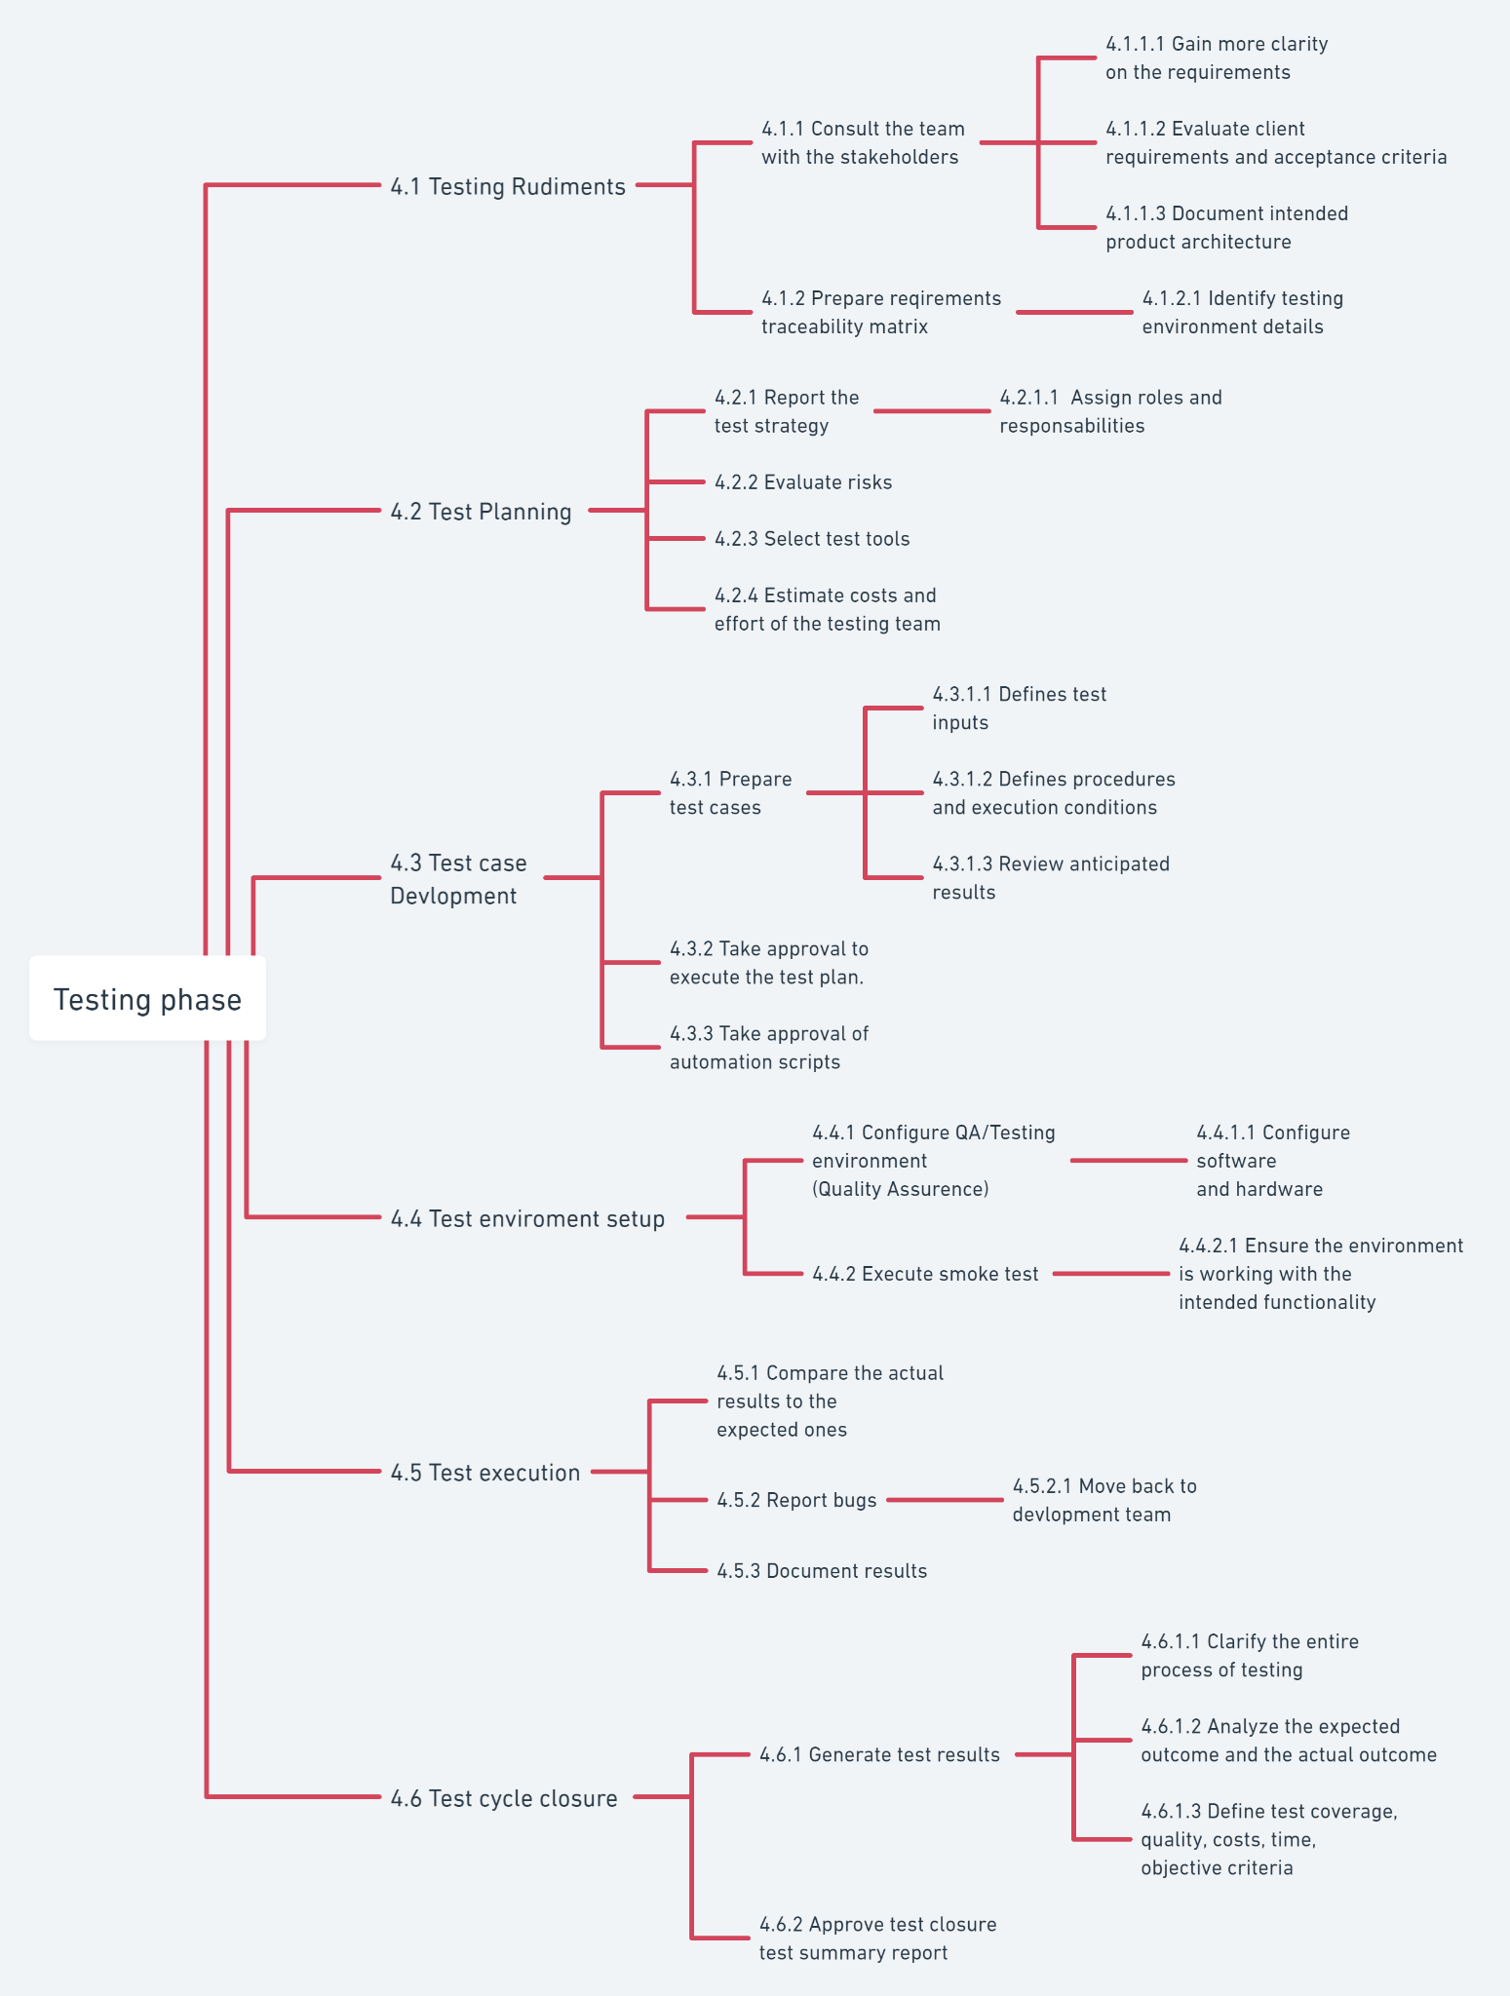

#### 5.1.2.5 Project’s WBS

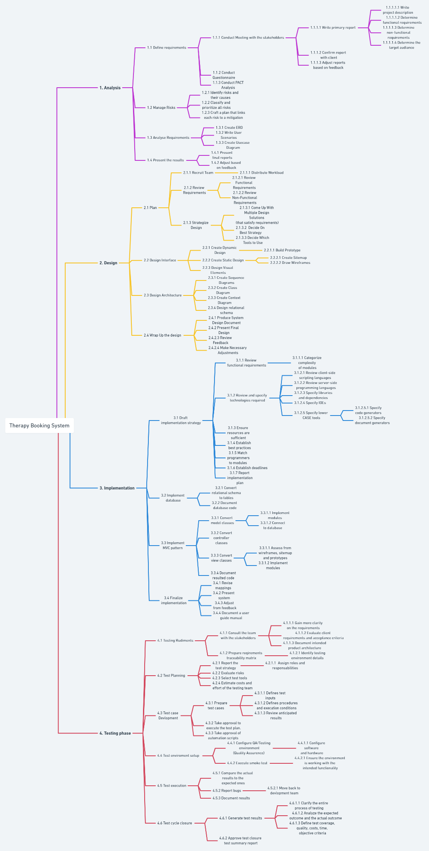

### 5.1.3 Resource Allocation

|  |  |  |
| --- | --- | --- |
| Phase | Resources | Total Cost |
| Analysis  (Rahma) | * Work:   + Analysis Manager = $10,000   + Analysis Employees = 5* $3,000 = $15,000 * Material:   + Meetings needed material(Food, Paper,Pens,..) = $7,000 * Cost:   + Analysis needed tools = $2,000 | Resources Costs + Estimated Overhead Costs =  $32,000 + 10,000 =  $42,000 |
| Design  (Jacinta) | * Work:   + Design Manager = $8,500   + Design Employees = 3 * $4,500 = $13,500 * Material:   + Paper ≈ $100   + Whiteboard ≈ 2 * $250 = $500   + Markers, pens, pencils, rulers, etc. (stationary) ≈ $250   + PC ≈ 3 * $300 = $900 * Cost:   + Figma Subscriptions ≈ $100   + Adobe Illustrator Subscriptions ≈ $100 | Resources Costs + Estimated Overhead Costs = $23,950 + $9,050  = $33,000 |
| Implementation  (Ashraf) | * Work:   + Implementation Manager = $10000   + Implementation Employees = 4 * $5000 = $20000. * Material:   + paper ≈ $100.   + printer ≈ 4 * $200 = $800.   + PC ≈ 4 * $300 = $12,000. * Cost:   + IDEs subscriptions ≈ $200.   + Microsoft Office products ≈ $200.   + Server hosting ≈ $200. | Resources Costs + Estimated Overhead Costs = $43,500 + $11,500 = $55,000 |
| Testing  (Yasmine) | * Work:   + Testing Manger = $5000   + Testing Employees=4*$4000 * Material:   + paper ≈ $100   + Scanner:$500 * Cost:   + Server Maintenance ≈ $200   + Testing Tools=$20000 | Resources Costs + Estimated Overhead Costs =$29,800+$12,200=$42,000 |

(Note that the currency is implicitly converted from L.E to $ for ease of use.)

Total Project Cost:

$42,000 + $33,000 + $55,000 + $42,000 = $172,000

## 5.2 Work Planning

### 5.2.1 Scheduling Requirements

Note 1: the precedence table for all the project is located at 5.2.1.5

Note 2: The following link contains the MS project files incase they aren’t clear in the images provided below: <https://drive.google.com/drive/folders/1bvk_VlFC444ptu0pshDGYfu8x_MRlgwK?usp=sharing>

#### 5.2.1.1 Analysis’s Precedence Table & CPM Network (Rahma)

|  |  |  |  |
| --- | --- | --- | --- |
| Activity | Description | Predecessor | Duration (days) |
| A | Write project description |  | 1 |
| B | Determine functional requirements |  | 1 |
| C | Determine non-functional requirements |  | 1 |
| D | Determine the target audience |  | 1 |
| E | Confirm report with clients | A,B,C,D | 1 |
| F | Adjust reports based on feedback | E | 2 |
| G | Conduct Questionnaire | E,F | 3 |
| H | Conduct PACT Analysis | G | 3 |
| I | Identify risks and their causes | F,H | 2 |
| J | Classify and prioritize all risks | I | 2 |
| K | Craft a plan that links each risk to a mitigation | I,J | 3 |
| L | Create ERD | F | 3 |
| M | Write User Scenarios | B,F | 2 |
| N | Create Usecase Diagram | B,F | 2 |
| O | Present final reports | F,G,K,M,N,L | 1 |
| P | Adjust based on feedback | O | 2 |

CPM Network: <https://whimsical.com/1-analysis-cpm-MccqhQetHK6sEPwCLQqxy8>

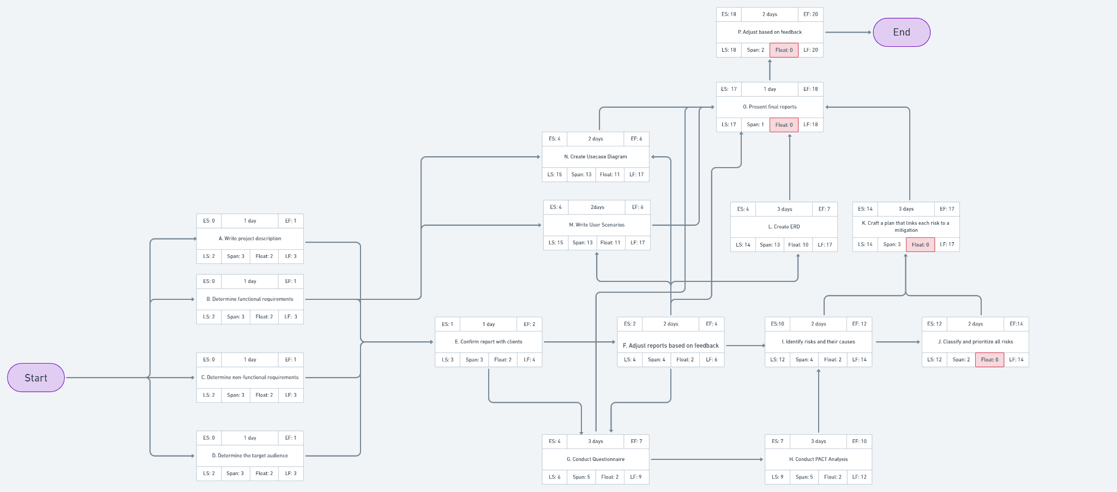

There are no critical paths in this CPM.

Gantt Chart (extra day added in first task to display different baselines):

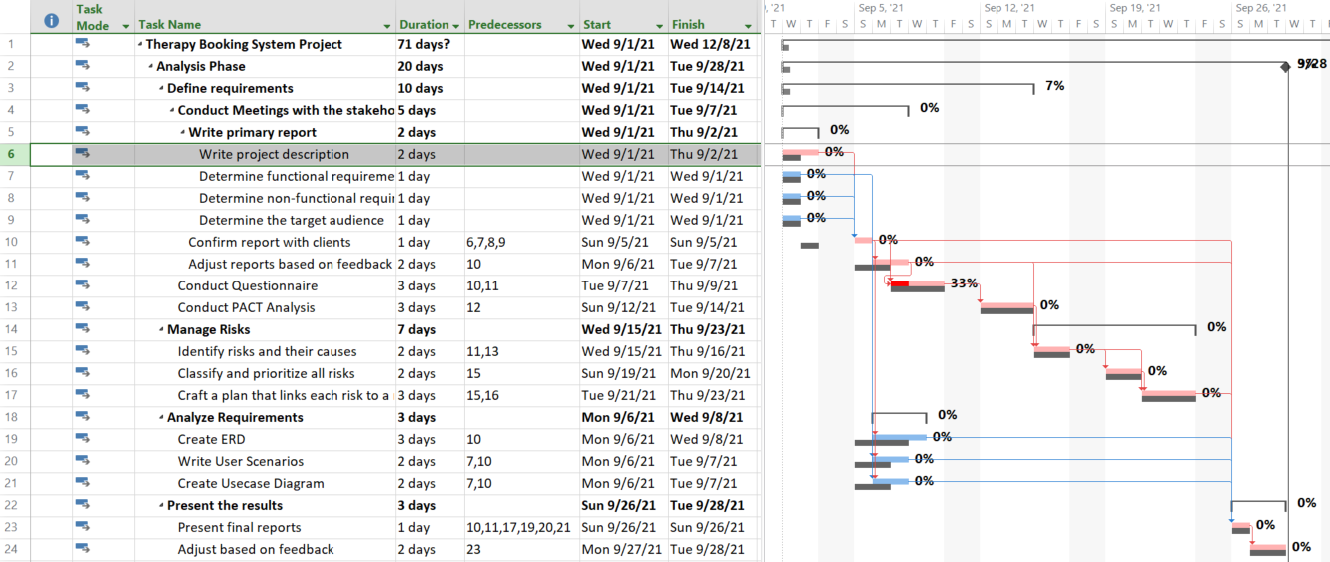

#### 5.2.1.2 Design’s Precedence Table & CPM Network (Jacinta)

|  |  |  |  |
| --- | --- | --- | --- |
| Activity | Description | Predecessor | Duration (days) |
| Q | Distribute Workload |  | 1 |
| R | Review Functional Requirements |  | 1 |
| S | Review Non-Functional Requirements |  | 1 |
| T | Come Up With Multiple Design Solutions | Q, R, S | 4 |
| U | Decide On Best Strategy | T | 1 |
| V | Decide Which Tools to Use | U | 1 |
| W | Build Prototype | V, X, Y, Z | 5 |
| X | Create Sitemap | U | 2 |
| Y | Draw Wireframes | U | 2 |
| Z | Design Visual Elements | U | 4 |
| AA | Create Sequence Diagrams | W | 2 |
| AB | Create Class Diagram | W | 2 |
| AC | Create Context Diagram | W | 2 |
| AD | Design relational schema | W | 2 |
| AE | Produce System Design Document | AA, AB, AC, AD | 2 |
| AF | Present Final Design | AE | 1 |
| AG | Review Feedback | AF | 1 |
| AH | Make Necessary Adjustments | AG | 3 |

CPM Network: <https://whimsical.com/2-design-cpm-LdG95ykTK8sfidVAEDoN1K>

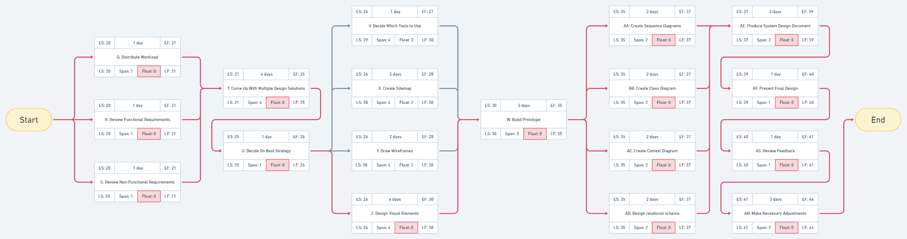

CPM Path: Start → Q,R,S → T → U → Z → W → AA,AB,AC,AD → AE → AF → AG → AH → End

Gantt Chart (extra day added in first task to display different baselines):

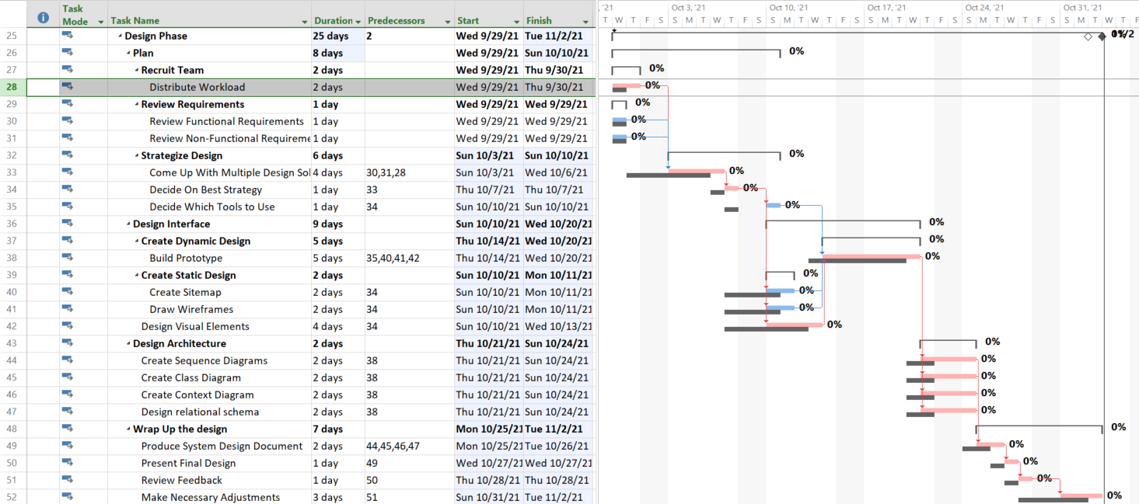

#### 5.2.1.3 Implementation’s Precedence Table & CPM Network (Ashraf)

|  |  |  |  |
| --- | --- | --- | --- |
| Activity | Description | Predecessor | Duration (days) |
| AI | Categorize complexity of modules |  | 2 |
| AJ | Review client-side scripting languages |  | 1 |
| AK | Review server-side programming languages |  | 1 |
| AL | Specify libraries and dependencies | AI | 1 |
| AM | Specify IDEs |  | 1 |
| AN | Specify code generators |  | 1 |
| AO | Specify document generators |  | 1 |
| AP | Ensure resources are sufficient | AJ, AK, AL,  AM, AN, AO, | 3 |
| AQ | Establish best practices |  | 1 |
| AR | Match programmers to modules | AL | 2 |
| AS | Establish deadlines | AP, AR, AQ | 1 |
| AT | Report implementation plan | AS | 1 |
| AU | Convert relational schema to tables | AT | 3 |
| AV | Document database code | AU | 1 |
| AW | Implement modules (model) | AV | 5 |
| AX | Connect to database | AW | 1 |
| AY | Convert controller classes | AW | 2 |
| AZ | Assess from wireframes, sitemaps, and prototypes | AT | 1 |
| BA | Implement modules (view) | AZ | 3 |
| BB | Document resulted code | AX, AY, BA | 2 |
| BC | Revise mappings | BB | 1 |
| BD | Present system | BC | 1 |
| BE | Adjust from feedback | BD | 3 |
| BF | Document a user guide manual | BE | 1 |

CPM Network: <https://whimsical.com/3-implementation-cpm-UZSDYBanmWzLhDJ1X7of7v>

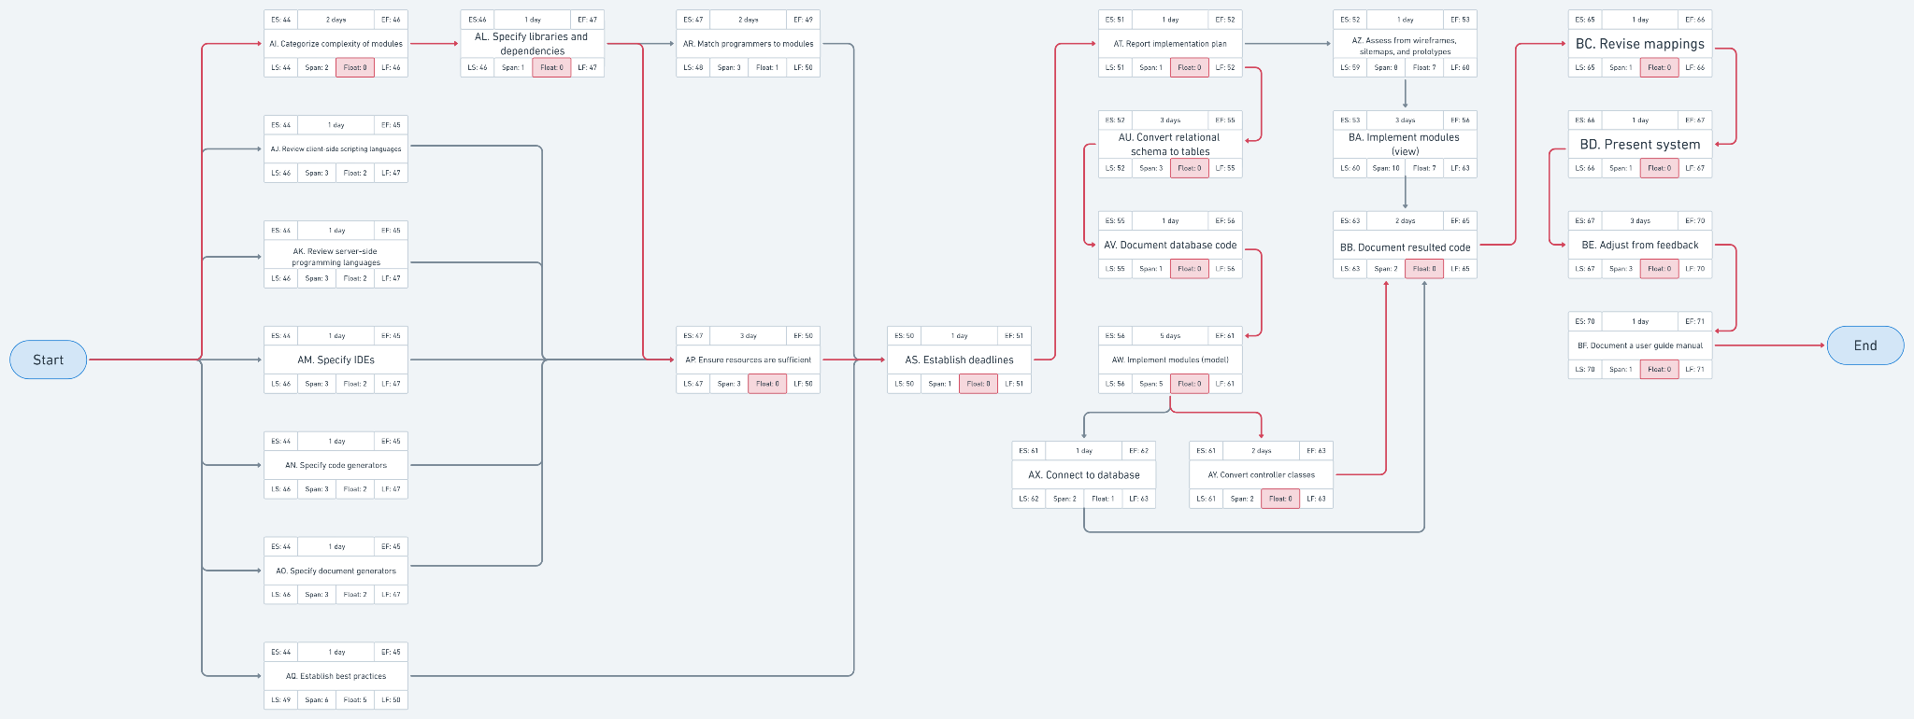

CPM Path: Start → AI → AL → AP → AS → AT → AU → AV → AW → AY → BB → BC → BD → BE → BF → End

Gantt Chart (extra day added in first task to display different baselines):

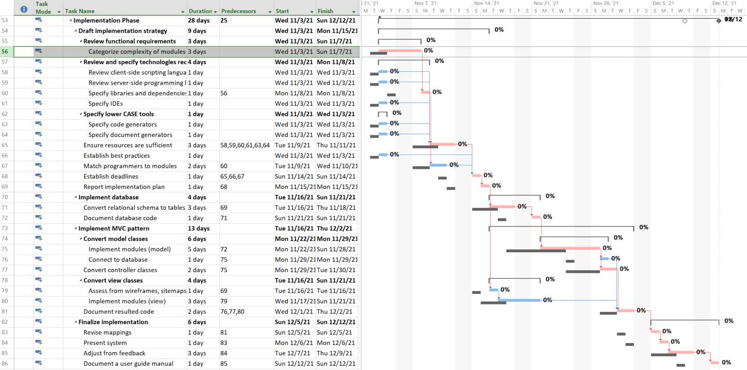

#### 5.2.1.4 Testing’s Precedence Table & CPM Network (Yasmine)

|  |  |  |  |
| --- | --- | --- | --- |
| Activity | Description | Predecessor | Duration (days) |
| BG | Gain more clarity on the requirements |  | 1 |
| BH | Evaluate client requirements and acceptance criteria |  | 1 |
| BI | Document intended product architecture | BG,BH | 3 |
| BJ | Identify testing environment details | BI | 2 |
| BK | Assign roles and responsibilities | BJ | 1 |
| BL | Evaluate risks |  | 1 |
| BM | Select test tools |  | 1 |
| BN | Estimate costs and effort of the testing team | BK,BL,BM | 1 |
| BO | Defines test inputs | BM | 1 |
| BP | Defines procedures and execution conditions | BO | 1 |
| BQ | Review anticipated results | BN,BP | 2 |
| BR | Take approval to execute the test plan | BQ | 1 |
| BS | Take approval of automation scripts | BR | 1 |
| BT | Configure software and hardware | BS | 3 |
| BU | Ensure the environment is working with the intended functionality |  | 1 |
| BV | Compare the actual results to the expected ones | BT | 1 |
| BW | Move reported bugs back to the development team | BV | 1 |
| BX | Document results | BW | 1 |
| BY | Clarify the entire process of testing | BU | 1 |
| BZ | Analyze the expected outcome and the actual outcome | BX | 1 |
| CA | Define test coverage, quality, costs, time, objective criteria |  | 1 |
| CB | Approve test closure test summary report | BY,BZ,CA | 3 |

CPM Network: <https://whimsical.com/4-testing-cpm-VK8NsKa7BQKk4b1vM6EZa1>

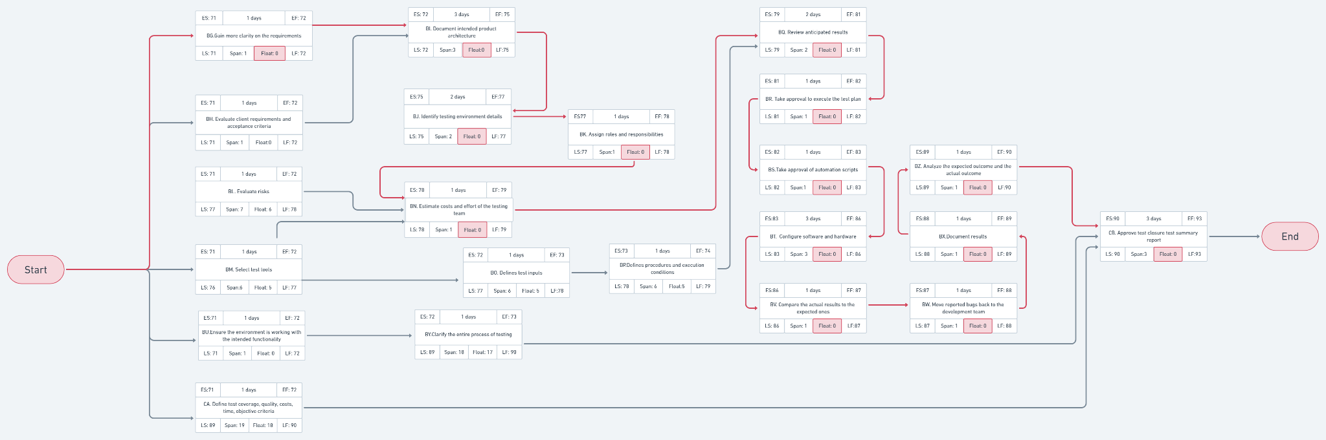

Critical Path: Start → BG → BI → BJ → BK → BN → BQ → BR → BS → BT → BV → BW → BX → BZ → CB → End

Gantt Chart (extra day added in first task to display different baselines):

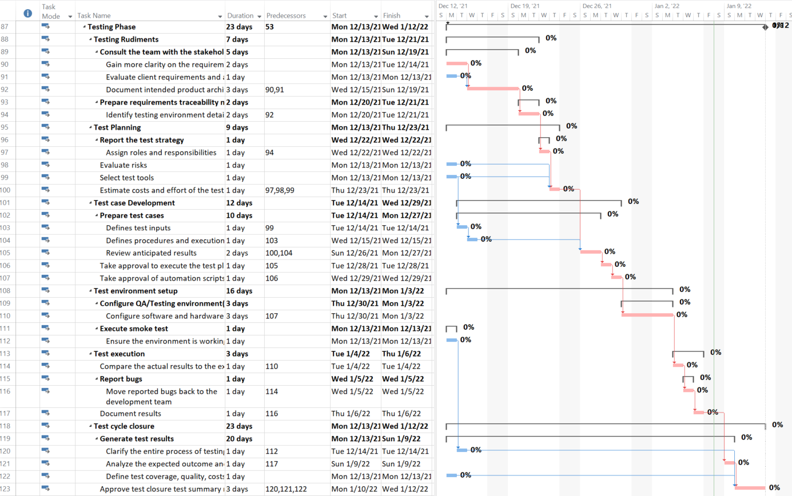

#### 5.2.1.5 Project’s Precedence Table & CPM Network

|  |  |  |  |
| --- | --- | --- | --- |
| Activity | Description | Predecessor | Duration (days) |
| A | Write project description |  | 1 |
| B | Determine functional requirements |  | 1 |
| C | Determine non-functional requirements |  | 1 |
| D | Determine the target audience |  | 1 |
| E | Confirm report with clients | A,B,C,D | 1 |
| F | Adjust reports based on feedback | E | 2 |
| G | Conduct Questionnaire | E,F | 3 |
| H | Conduct PACT Analysis | G | 3 |
| I | Identify risks and their causes | F,H | 2 |
| J | Classify and prioritize all risks | I | 2 |
| K | Craft a plan that links each risk to a mitigation | I,J | 3 |
| L | Create ERD | F | 3 |
| M | Write User Scenarios | B,F | 2 |
| N | Create Usecase Diagram | B,F | 2 |
| O | Present final reports | F,G,K,M,N,L | 1 |
| P | Adjust based on feedback | O | 2 |
| Q | Distribute Workload |  | 1 |
| R | Review Functional Requirements |  | 1 |
| S | Review Non-Functional Requirements |  | 1 |
| T | Come Up With Multiple Design Solutions | Q, R, S | 4 |
| U | Decide On Best Strategy | T | 1 |
| V | Decide Which Tools to Use | U | 1 |
| W | Build Prototype | V, X, Y, Z | 5 |
| X | Create Sitemap | U | 2 |
| Y | Draw Wireframes | U | 2 |
| Z | Design Visual Elements | U | 4 |
| AA | Create Sequence Diagrams | W | 2 |
| AB | Create Class Diagram | W | 2 |
| AC | Create Context Diagram | W | 2 |
| AD | Design relational schema | W | 2 |
| AE | Produce System Design Document | AA, AB, AC, AD | 2 |
| AF | Present Final Design | AE | 1 |
| AG | Review Feedback | AF | 1 |
| AH | Make Necessary Adjustments | AG | 3 |
| AI | Categorize complexity of modules |  | 2 |
| AJ | Review client-side scripting languages |  | 1 |
| AK | Review server-side programming languages |  | 1 |
| AL | Specify libraries and dependencies | AI | 1 |
| AM | Specify IDEs |  | 1 |
| AN | Specify code generators |  | 1 |
| AO | Specify document generators |  | 1 |
| AP | Ensure resources are sufficient | AJ, AK, AL,  AM, AN, AO, | 3 |
| AQ | Establish best practices |  | 1 |
| AR | Match programmers to modules | AL | 2 |
| AS | Establish deadlines | AP, AR, AQ | 1 |
| AT | Report implementation plan | AS | 1 |
| AU | Convert relational schema to tables | AT | 3 |
| AV | Document database code | AU | 1 |
| AW | Implement modules (model) | AV | 5 |
| AX | Connect to database | AW | 1 |
| AY | Convert controller classes | AW | 2 |
| AZ | Assess from wireframes, sitemaps, and prototypes | AT | 1 |
| BA | Implement modules (view) | AZ | 3 |
| BB | Document resulted code | AX, AY, BA | 2 |
| BC | Revise mappings | BB | 1 |
| BD | Present system | BC | 1 |
| BE | Adjust from feedback | BD | 3 |
| BF | Document a user guide manual | BE | 1 |
| BG | Gain more clarity on the requirements |  | 1 |
| BH | Evaluate client requirements and acceptance criteria |  | 1 |
| BI | Document intended product architecture | BG,BH | 3 |
| BJ | Identify testing environment details | BI | 2 |
| BK | Assign roles and responsibilities | BJ | 1 |
| BL | Evaluate risks |  | 1 |
| BM | Select test tools |  | 1 |
| BN | Estimate costs and effort of the testing team | BK,BL,BM | 1 |
| BO | Defines test inputs | BM | 1 |
| BP | Defines procedures and execution conditions | BO | 1 |
| BQ | Review anticipated results | BN,BP | 2 |
| BR | Take approval to execute the test plan | BQ | 1 |
| BS | Take approval of automation scripts | BR | 1 |
| BT | Configure software and hardware | BS | 3 |
| BU | Ensure the environment is working with the intended functionality |  | 1 |
| BV | Compare the actual results to the expected ones | BT | 1 |
| BW | Move reported bugs back to the development team | BV | 1 |
| BX | Document results | BW | 1 |
| BY | Clarify the entire process of testing | BU | 1 |
| BZ | Analyze the expected outcome and the actual outcome | BX | 1 |
| CA | Define test coverage, quality, costs, time, objective criteria |  | 1 |
| CB | Approve test closure test summary report | BY,BZ,CA | 3 |

CPM Network: <https://whimsical.com/5-tbs-cpm-NdyWAGCu55U9y56VZhFrKc>

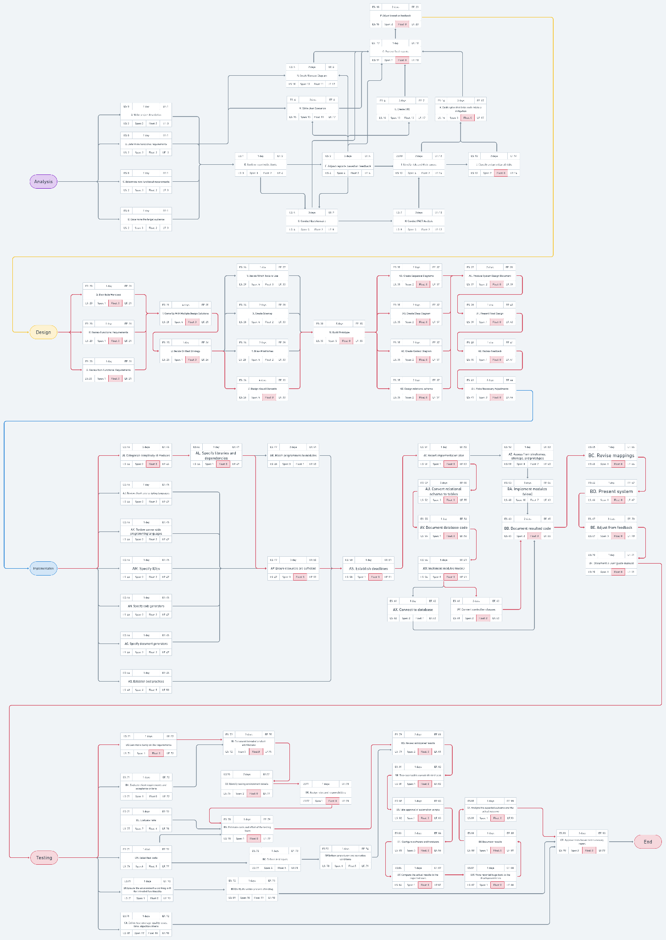

## 5.3 Risk Management

### 5.3.1 Analysis’s Risk Management (Rahma)

#### 5.3.1.1 Risk Assessments

|  |  |  |  |
| --- | --- | --- | --- |
| **Risk** | **Description** | **Type** | **Exposure** |
| Low Stakeholder Engagement | In case the project stakeholders are not engaging with the project team as frequently as they should to maintain a high productivity level, it may lead to a project delay. | Generic | 7 days * 0.3  = 2.1 days |
| The Gold Plating Phenomenon | A phenomenon in which analysts, designers, developers and testers elaborate and exaggerate on the details too much and way beyond the original scope without them realizing, It may lead to a project delay. | Generic | 3 days * 0.2  = 0.6 days |
| Misunderstand the requirements | If the analysts misunderstood the stakeholders requirements, that could lead to a project delay. | Specific | 3 days * 0.4  = 1.2 days |
| Inconsistent tools | If the analysis team members didn’t agree on a specific tool to use in creating the ERD and the Use case diagram, and each one uses a different tool from the other in making his/her part, they will face a huge problem when collabing the work in one project, that could lead to a delay in the project. | Specific | 2 days *0.2  = 0.4 days |
| Sudden change in the specifications | In case the project stakeholders agree on specific requirements and change them later, that could lead to a delay in the project. | Specific | 6 days * 0.7  = 4.2 days |

#### 5.3.1.2 Misunderstand the requirements risk

##### 5.3.1.2.1 Risk Reduction’s Resolution & Leverage

Method to reduce risk (resolution):

By conducting more than two meetings to make sure that these requirements are what the stakeholders want, and trying to repeat the requirements but in different words to avoid any misunderstanding. by applying this method the probability of loss will decrease from 0.4 to 0.1

Before resolution:

Probability of loss: 0.4

Loss: 3 days

Exposure (REB)= 0.4 * 3 days= 1.2 days

After resolution:

Probability of loss: 0.1

Loss: 3 days

Exposure (REA) = 0.1 * 3 days= 0.3 days

Cost of risk reduction (RR) = 2 days

Risk Reduction Leverage = (REB - REA) / RR = (1.2 - 0.3) / 2 = 0.45

∵ RRL < 1 ∴ not worth doing

##### 5.3.1.2.2 Contingency Plan

If the requirements were misunderstood then it is the analyst manager’s fault, an amount of his salary will be taken off, or in a worst case he/she will be fired but then the project will be delayed a week maximum in order to find a new qualified analyst manager.

#### 5.3.1.3 Sudden change in the specifications risk

##### 5.3.1.3.1 Risk Reduction’s Resolution & Leverage

Method to reduce risk (resolution):

A document will be sent to all the stakeholders right after the final meeting, with all the meeting content (what was said in the meeting), clear agreement will be done with the customer or stakeholders around the response time; the time they need to change or approve all the requirements in the document, if they didn’t respond within the time limit, the analysts will consider the data they have for the project are the final data and will not accept any changes later on, the stakeholders should respond in 2 days not more than that. By applying this solution the project will be delayed 2 days not 6 days but this method will need an extra day to be done.

Before resolution:

Probability of loss: 0.7

Loss: 6 days

Exposure (REB)= 0.7 * 6 days = 4.2 days

After resolution:

Probability of loss: 0.7

Loss: 2 days

Exposure (REA) = 0.7 * 2 days = 1.4 days

Cost of risk reduction (RR) = 1 day

Risk Reduction Leverage (RRL) = (REB - REA) / RR = (4.2 - 1.4)/1 = 2.8

∵ RRL > 1 ∴ this solution is worth to be done.

##### 5.3.1.3.2 Contingency Plan

If a sudden change happens in the requirements after the time limit; the analyst manager should contact the stakeholders giving them 2 ways in order to continue this project, the first is to ignore the new requirements or the changes they want in the project and stick to what they said, the second is to add an extra amount of money to encourage the employees to start again with the changes needed.

### 5.3.2 Design’s Risk Management (Jacinta)

#### 5.3.2.1 Risk Assessments

|  |  |  |  |
| --- | --- | --- | --- |
| **Risk** | **Description** | **Type** | **Exposure** |
| Experience | An inexperienced team that does not have the required skill set will require more time to accomplish the project. | Generic | 7 days * 0.1  = 0.7 days |
| Health | If a member of the team falls ill, a delay in the project will occur, as the rest of the team must deal with that member’s workload. | Generic | 5 days * 0.3  = 1.5 days |
| Requirements | If the design team faces ambiguity when reading the requirements document, they may find it difficult to clearly understand the needed requirements, and thus will take more time to discern them and design accordingly. | Specific | 3 days * 0.25  = 0.75 days |
| Tools | If, when the team begins prototyping, they find that their previously chosen tools are not able to fully accommodate their design, they will have to reconsider new tools to use, and begin prototyping anew. | Specific | 5 days * 0.4  = 2 days |
| Architecture | If the architecture created by the design team becomes more complex than anticipated, this may overwhelm the team, which may cause confusion and reduce the overall consistency. The team will require more time than expected in order to accurately create and verify their architecture. | Specific | 6 days * 0.5  = 3 days |

Complex architecture has the highest risk, whereas the lowest risk is lack of experience.

#### 5.3.2.2 Tools Risk

##### 5.3.2.2.1 Risk Reduction’s Resolution & Leverage

Method to reduce risk (resolution):

If the team, before choosing which tools to use, more carefully researches the capabilities of the tools, as well as looking at other projects in which the tools have been applied and assessing the similarities/differences in their requirements, the team will have a better understanding of whether or not the tools will suit the project. Doing this will **reduce the probability** from **0.4 to 0.1**, however will take the team **one more day**.

Before resolution:

Probability of loss: 0.4

Loss: 5 days

Exposure (REB)= 0.4 * 5 days = 2 days

After resolution:

Probability of loss: 0.1

Loss: 5 days

Exposure (REA) = 0.1 * 5 days = 0.5 days

Cost of risk reduction (RR) = 1 day

Risk Reduction Leverage = (REB - REA) / RR = (2 - 0.5) / 1 = 1.5

Since the RRL > 1, this solution is worth applying.

##### 5.3.2.2.2 Contingency Plan

If the chosen tools are still unable to apply all required features of the design, further activities will be halted, and the design team must go back and redecide on a new set of tools, based on the experienced downfalls of the ones they attempted using. Once a new decision has been made, they must reiterate the prototyping process from scratch using the new tools.

#### 5.3.2.3 Architecture Risk

##### 5.3.2.3.1 Risk Reduction’s Resolution & Leverage

Method to reduce risk (resolution):

By having more frequent team meetings to discuss all the new advances to the architecture incrementally, and by making sure to update the rest of the team with every development that occurs, the team will be much less likely to still be confused if the architecture grows larger than initially expected. This will **reduce the time** lost from **6 days to 2 days**, but will cost the team **an extra 1.5 days**.

Before resolution:

Probability of loss: 0.5

Loss: 6 days

Exposure (REB)= 0.5 * 6 days = 3 days

After resolution:

Probability of loss: 0.5

Loss: 2 days

Exposure (REA) = 0.5 * 2 days = 1

Cost of risk reduction (RR) = 1.5 days

Risk Reduction Leverage (RRL) = (REB - REA) / RR = (3 - 1) / 1.5 = 1.33

As the RRL > 1, it is worth doing this solution.

##### 5.3.2.3.2 Contingency Plan

If the architecture grew out of hand, and there was an overall confusion in understanding and designing it amongst the team, the entire design team would have to set up a meeting and discuss every nuance of the architecture, until no more conflicts exist and the whole team understands it clearly. This meeting may even span across multiple days before the whole team thoroughly comprehends all aspects, delaying further activities until then.

### 5.3.3 Implementation’s Risk Management (Ashraf)

#### 5.3.3.1 Risk Assessments

|  |  |  |  |
| --- | --- | --- | --- |
| **Risk** | **Description** | **Type** | **Exposure** |
| Communication | Improper team cooperation can lead to waste of time & resources. | Generic | 3 days * 0.05  = 0.15 days |
| System Errors | Potential system crashes/technical errors will lead to delays for the project’s deployment. | Generic | 5 days * 0.8  = 4 days |
| Funding | The project board may provide insufficient funds to maintain servers’ performance and handle an increased amount of user base for the website or the project may need more funding than the estimated amount. | Specific | 7 days * 0.1  = 0.7 days |
| Security | The website deals with very sensitive information regarding the patients (their session logs, current mental health, etc), so any hole in the system’s security protocols could dissatisfy the client; leading to a delay in the project’s deployment. | Specific | 6 days * 0.5  = 3 days |
| Dependency | Related to the task “Specify libraries and dependencies”; the project might end up with multiple libraries that are imported to apply very few methods related to their respective libraries, thus maintaining and updating the versions of different dependencies to be compatible with other libraries is done for a little benefit. | Specific | 6 days * 0.6  = 3.6 days |

System errors have the highest risk, while Funding has the lowest risk.

#### 5.3.3.2 Security Risk

##### 5.3.3.2.1 Risk Reduction’s Resolution & Leverage

Method to reduce risk (resolution):

Since the risk is related to data breaches, which mainly occurs due to sql injections, the development team should make sure the implementation of the database is done in such a way that prevents sql injections (for example, by making sure querying is done through parameterized queries, ORM, or stored procedures, etc). This solution **decreases the** **probability** of this security risk **from 0.5 to 0.25**, but could **cost** the development team **an extra day of work** to ensure that any previously written code is refactored.

Before resolution:

Probability of loss: 0.5

Loss: 6 days

Exposure (REB)= 6 days * 0.5 = 3 days

After resolution:

Probability of loss: 0.25

Loss: 6 days

Exposure (REA) = 6 days * 0.25 = 1.5 days

Cost of risk reduction (RR) = 1 day

Risk Reduction Leverage = (REB - REA) / RR = (3 - 1.5) / 1 = 1.5 / 1 = 1.5

Since RRL = 1.5 > 1, therefore it is worthwhile to implement this solution.

##### 5.3.3.2.2 Contingency Plan

If other methods were found to breach the data during the testing phase, then the project’s method of implementing security measures will have to be re-implemented and project deployment will be delayed till the stakeholders are sure that the project is secure.

#### 5.3.3.3 Dependency Risk

##### 5.3.3.3.1 Risk Reduction’s Resolution & Leverage

Method to reduce risk (resolution):

Since the development team will need a specific functionalities of any imported library, two operations could be followed to avoid time spent on updating and maintaining the libraries’ versions to be compatible with the rest of the code:

1. The development team will implement the functions (modules) that they need by themselves; this ensures no maintenance of version as the development team are sure the code will work with the rest of the project’s software.
2. If the team couldn’t implement a required function, they will consult the stakeholders to update their functional requirements to match the new possible functionalities of the project.

This is expected to **reduce time** consumed in managing the libraries (debugging dependency issues, maintaining libraries’ versions, etc) **from 6 days to 2 days**, but it is expected to **cost** the development team **3 days** to create the required functions themselves, and update the stakeholder’s functional requirements.

Before resolution:

Probability of loss: 0.6

Loss: 6 days

Exposure (REB) = 6 days * 0.6 = 3.6 days

After resolution:

Probability of loss: 0.6

Loss: 2 days

Exposure (REA) = 2 * 0.6 = 1.2 days

Cost of risk reduction (RR) = 3 days

Risk Reduction Leverage (RRL) = (REB - REA) / RR = (3.6 - 1.2) / 3 = 2.4 / 3 = 0.8

Since RRL = 0.8 < 1, it is not worthwhile to implement this solution.

##### 5.3.3.3.2 Contingency Plan

If there were library issues found, the development team will track the library that most contributed to this issue (either it be system slowdown, dependency problems with other libraries, etc), and find another library that provides similar functionalities and replace it with the current library that caused the issue.

### 5.3.4 Testing’s Risk Management (Yasmine)

#### 5.3.4.1 Risk Assessments

|  |  |  |  |
| --- | --- | --- | --- |
| **Risk** | **Description** | **Type** | **Exposure** |
| Budget | the unexpected overpriced of the determinant resources, tools and materials than the  estimated amount , which may lead to conflict with the investors of the project. | Generic | 3 days *0.4  = 1.2 days |
| Natural Disasters | It results from natural processes of the earth like earthquakes, floods, volcanic eruptions..  which affects the test plan especially if the team exists in the same geographic area. | Generic | 7 days*0.05  = 0.35 days |
| Testing Dependency | Non availability of independent test environment and accessibility so, the schedule gets impacted which leads to delay of the test execution. | Specific | 5 days*0.4  =2 days |
| Postponement | Delayed testing due to new issues. Some defects that may be raised during testing can yield to an issue that will need time to resolve. | Specific | 3 days *0.3  =0.9 days |
| Incompatible requirements | The incompatibility of the actual results with the estimated one during the test execution leads to specifying additional time which may hinder the progress of the project. | Specific | 3 days * 0.1  = 0.3 days |

#### 5.3.4.2 Testing Dependency Risk

##### 5.3.4.2.1 Risk Reduction’s Resolution & Leverage

Method to reduce risk (resolution):

From the test environment setup process is to ensure that the environment is working with the intended functionality and each team member works on his role in its specific time to avoid the dependency. Also the team has to plan a testing strategy that makes the testing processes occur in parallel independently.This is expected to reduce time during test environment setup from 5 days to 2 day which may cost human resources assigned to specific roles.

Before resolution:

Probability of loss: 0.4

Loss: 5 days

Exposure (REB)= 5 * 0.4 = 2 days

After resolution:

Probability of loss: 0.4

Loss: 2 days

Exposure (REA) = 2 * 0.4 = 0.8 days

Cost of risk reduction (RR) = 6 days

Risk Reduction Leverage = (REB - REA) / RR = 2-0.8/6=0.2

Since RRL is 0.2 < 1, we shouldn’t apply this risk.

##### 5.3.4.2.2 Contingency Plan

If the dependency issue occured the team leader has to meet the stakeholders and the investors of the project to reschedule the due date of the project then the team leader should to urgently provide human resources to continue the project progress.

#### 5.3.4.3 Incompatible requirements Risk

##### 5.3.4.3.1 Risk Reduction’s Resolution & Leverage

Method to reduce risk (resolution):

During each stage of the functional testing, the team must reconsider the customer requirements document to processes the outcomes. However, the non-functional testing like load testing, stress testing, endurance testing, spike testing. Cannot be tested until the project is done, therefore it can be compared to the estimated requirements document, but this may consume more time somehow that have to be rescheduled in the testing plan. this is expected to reduce incompatibility outcomes from 3 days to 0.5 day.

Before resolution:

Probability of loss: 0.1

Loss: 3 days

Exposure (REB)= 0.1*3=0.3 days

After resolution:

Probability of loss: 0.1

Loss: 0.5 (or you could change loss , but leave probability as before)

Exposure (REA) = 0.1*0.5=0.02 days

Cost of risk reduction (RR) = 1 day

Risk Reduction Leverage (RRL) = (REB - REA) / RR = 0.3-0.02/1=0.28

Since risk reduction is 0.28 < 1, we shouldn’t apply this risk.

##### 5.3.4.3.2 Contingency Plan

postponement of the project submission due to incompatibility of the outcomes indicates

bad impression for the company so all the team members have to be charged for the shortage

in their responsibilities.